|  |  |  |  |  |  |  |  |  |  |  |  |  |
| --- | --- | --- | --- | --- | --- | --- | --- | --- | --- | --- | --- | --- |
| Roll No |  |  |  |  |  |  |  |  |  |  |  |  |



**Presidency University**

**Bengaluru**

**SCHOOL OF ENGINEERING**

**END TERM EXAMINATION – AUG2024**

**Even Semester**: 2023 - 24

**Course Code**: CIV 6008

**Course Name**: ADVANCED DESIGN OF STEEL STRUCTURES

**Program & Sem**: M.TECH (BCT) & II

**Date**: Aug 2024

**Time**:

**Max Marks**: 100

**Weightage**: 50%

**Instructions:**

1. *Assume any data if required.*
2. *Use of IS800 and SP-6(1) Steel tables are allowed*

**Part A [Memory Recall Questions]**

**Answer any FOUR Questions. Each question carries 05 marks. (4Qx 5M= 20M)**

1. Write short notes on framed connection and seated connection. (C.O.No.1) [Knowledge]
2. Determine the shape factor rectangular section of *b* x *d*. (C.O.No.2) [Knowledge]
3. Write the difference between Elastic analysis and plastic analysis. (C.O.No.2) [Knowledge]
4. Determine the collapse load for simply supported beam with point load (W) at the center of the span (L). (C.O.No.2) [Knowledge]
5. Write the requirements required for fire resistance level of steel structures. . (C.O.No.4)[Knowledge]
6. Enumerate the procedure to calculate the period of structural adequacy (PSA).

(C.O.No.4)[Knowledge]

**Part B [Thought Provoking Questions]**

**Answer any FOUR Questions. Each question carries 10 marks. (4Qx10M=40M)**

1. Determine the plastic moment capacity and shape factor of I-section as shown in Fig.Q.7. Take fy =250MPa. (C.O.No.2) [Comprehension]

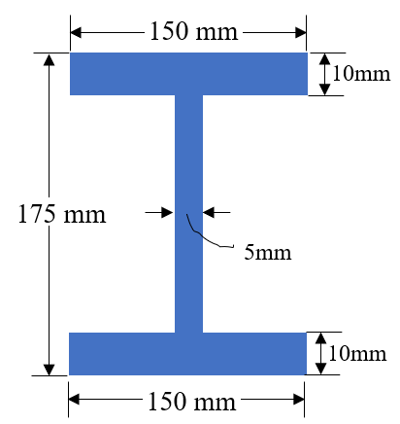

Fig. (Q.No.7)

1. Find the collapse load for simply supported beam with uniformly distributed load (w/m) over the entire span of length L(m). (C.O.No.2) [Comprehension]
2. Design the principal rafter of a fink type roof truss for the following data:

Design compressive load = 175 kN, design tensile load = 70 kN, length of rafter panel =2.235m, Use Fe415 grade steel. Take Ύm0 = 1.10 and Ύmb = 1.25. (C.O.No.3) [Comprehension]

1. Design the compression member of a roof truss for the following data.

Design compressive load = 165kN

Design tensile load = 60kN,

Length of rafter panel =3m

Use Fe415 grade steel. Take Ύm0 = 1.10 and Ύmb = 1.25. (C.O.No.3) [Comprehension]

1. Fire protection methods are basically dependent on the fire load, fire rating and the type of structural members. Explain in detail the commonly used fire protection methods.

(C.O.No.4) [Comprehension]

**Part C [Problem Solving Questions]**

**Answer any TWO Questions. Each question carries 20 marks (2Qx20M=40M)**

1. Design a gantry girder to be used in an industrial building carrying manually operated overhead travelling crane for the following data:

Crane Capacity = 220 kN , Self-Weight of Crane Girder excluding Trolley =200 kN

Self-Weight of Trolley, Electric Motor, Hook, etc. = 40kN

Appr. Minimum Approach of Crane Hook to the Gantry Girder = 1.20 m ,

Wheel Base = 3.2 m

Centre-to-Centre Distance between Gantry Rails = 17 m

Centre-to-Centre Distance between Columns (Span of Gantry Girder) =8 m

Self-Weight of Rail Section = 300 N/m, Diameter of Crane Wheels = 150mm

Assume fu = 410 MPa, fy =fyw =fyf = 250 MPa.

(C.O.No.3) [Application]

1. Design the principal tie member of a fink type roof truss for the following data. Design also its connection with a 12mm thick gusset plate using 20mm diameter bolts of grade 4.6.

Design tensile load = 200 kN

Design compressive load = 60kN

Length of rafter panel =5m

Use Fe415 grade steel. Take Ύm0 = 1.10 and Ύmb = 1.25

Perform check for block shear strength. (C.O.No.3) [Application]

1. Determine a) Heated perimeter b) section factor c) limiting steel temperature d) exposed area to mass ratio and e) the time at which limiting temperature is attained for the I-Section ISMB 500 @86.9 kg/m beams supporting a concrete floor for the following cases:

Case 1: 3-sided Exposure

Case2: 4-sided exposure

Take load factor rf = 0.866 and mass of steel = 7850kg/m3 (C.O.No.4) [Application]