|  |  |  |  |  |  |  |  |  |  |  |  |  |
| --- | --- | --- | --- | --- | --- | --- | --- | --- | --- | --- | --- | --- |
| Roll No |  |  |  |  |  |  |  |  |  |  |  |  |



**Presidency University**

**Bengaluru**

**SCHOOL OF INFORMATION SCIENCE**

**Make Up Examinations, July 2024**

**Date**: 10/07/2024

**Time**: 09:30am – 12:30pm

**Max Marks**: 100

**Weightage**: 50%

**Odd Semester**: III

**Course Code**: CSA2004

**Course Name**: Computer Networks

**Department: BCA**

**Instructions:**

1. *Read the all questions carefully and answer accordingly.*
2. *Do not write any matter on the question paper other than roll number.*

**PART A**

**Answer any SIX Questions. Each question carries 10 marks. (6Qx 10M= 60M)**

1. Given the data word 101001111 and the divisor 10111, demonstrate the generation of the CRC code word at the sender site using binary division **Application (CO2)**

1. Apply the OSI Reference model to explain the Functionalities of Each layer and

how they Interaction network communication **Application (CO1)**

1. Discuss how the Domain Name System (DNS) Works and its Importance in Networking

**Knowledge** (CO4)

1. Explain the Operation of TCP with the neat sketch **Comprehensive** (CO3)
2. Describe the Process of Connection Establishment and Termination Using the three-way handshake

**Knowledge**  (CO3)

1. Difference Between the Distance Vector Routing and Link State Routing

**Comprehensive** (CO3)

1. Describe the Components of a Data Communication System and list the Network Connecting Devices **Comprehensive (CO1)**

**PART B**

**Answer any TWO Questions. Each question carries 20 marks. (2Qx 20M= 40M)**

1. A block of addresses is granted to a small organization. We know that one of the addresses is 205.16.37.39/28. **Application (CO3)**

a. What is the first address in the block?

b. Find the last address for the block

c. Find the number of addresses

1. Given a network with 5 routers (A to E) connected with links having specific weights, use the distance vector routing algorithm to solve the following: **Application (CO3)**

1. Construct the initial routing table for each router.

2.Update the routing tables for A to E after exchanging information.

3.Determine the minimum distance between Node A and Node E.

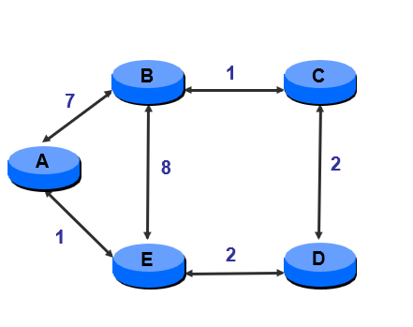

1. Draw a neat diagram describe in detail about the Network Topologies and Network Types

**Knowledge (CO1)**