|  |  |  |  |  |  |  |  |  |  |  |  |  |
| --- | --- | --- | --- | --- | --- | --- | --- | --- | --- | --- | --- | --- |
| Roll No |  |  |  |  |  |  |  |  |  |  |  |  |



**Presidency University**

**Bengaluru**

**SCHOOL OF INFORMATION SCIENCE**

**MCA make-up Examinations, July 2024**

**Date**: 03/07/2024

**Time**: 09:30am – 12:30pm

**Max Marks**: 100

**Weightage**: 50%

**Odd Semester**: I

**Course Code**: CSA4025

**Course Name**: Computer Networks

**Department:** School of Information Science

**Instructions:**

1. *Read the all questions carefully and answer accordingly.*
2. *Do not write any matter on the question paper other than roll number.*

**PART A**

**Answer any SIX Questions. Each question carries 10 marks. (6Qx 10M= 60M)**

1. Explain the TCP/IP architecture with a neat diagram. (CO1 , L2)
2. Analyze the type of address used in the different layers of TCP/IP model. (CO1, L3)
3. With a suitable example explain Dynamic Host Configuration Protocol. (CO2, L2)

1. Why subnetting is necessary? With suitable example, develop the concept of subneting in class B network. (CO2, L2)
2. A bit stream 1101011011 is transmitted using the standard CRC method. The generator polynomial is 10011. What is the actual bit string transmitted? (CO3, L3)
3. Consider sending a 2400-byte datagram into a link that has an MTU of 700 bytes. Suppose the original datagram is stamped with the identification number 422. How many fragments are generated? What are the values in the various fields in the IP datagram(s) generated related to fragmentation? (CO3, L3)
4. With neat diagram explain the frame structure of IEEE 802.11 wireless protocol. (CO4, L2)
5. Explain various HTTP request operations. (CO4, L2)

**PART B**

**Answer any TWO Questions. Each question carries 20 marks. (2Qx 20M= 40M)**

1. Implement the Link state routing algorithm and Distance Vector routing algorithm for the following graph. (CO2, L3)

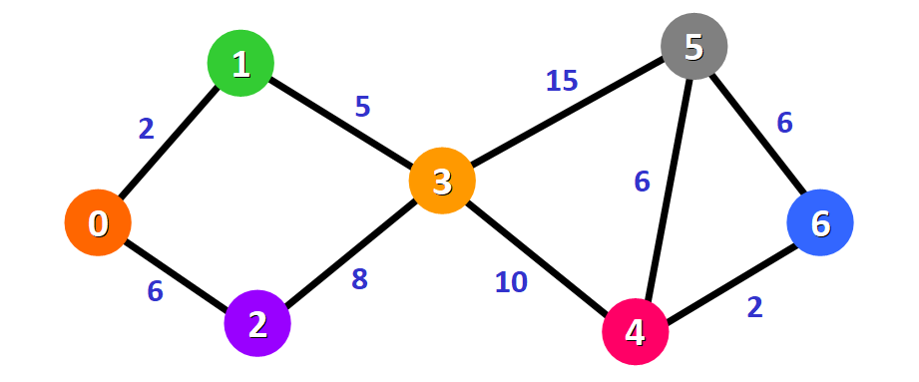

1. A bit stream 10011101 is transmitted using the standard CRC method. The generator polynomial is x3+1. (5)
2. What is the actual bit string transmitted?
3. Suppose the third bit from the left is inverted during transmission. How will receiver detect this error? (CO3, L3)
4. With a neat diagram explain IPV4 Datagram format, and compare IPV4 and IPV6. (CO2, L2)