|  |  |  |  |  |  |  |  |  |  |  |  |  |  |
| --- | --- | --- | --- | --- | --- | --- | --- | --- | --- | --- | --- | --- | --- |
| Roll No. |  |  |  |  |  |  |  |  |  |  |  |  |  |



**Presidency University**

**Bengaluru**

**SCHOOL OF ENGINEERING**

**Make-Up Examination July 2024**

**Date**: 02/07/2024

**Time**: 9:30am to 12:30pm

**Max Marks**: 100

**Weightage**: 50%

**Semester**: IV

**Course Code**: CSE2017

**Course Name:** Graph Theory and Combinatorics

**Program:** B.Tech

**Instructions:**

1. *Read all the questions carefully and answer accordingly.*
2. *Question paper consists of 3 parts.*
3. *Scientific and Non-programmable calculators are permitted.*

**Part A [Memory Recall Questions]**

**Answer any FIVE questions 5Q x 4M = 20M**

1. Among a group of students, 49 study Physics, 37 study English and 21 study Biology.If 9 of these students study Physics and English, 5 study English and Biology, 4 study Physics and Biology and 3 study Physics, English and Biology,

find the number of students in the group. (CO1) [Knowledge]

2. Define pseudo graph. Give one example (CO2) [Knowledge]

3. Can there be a graph with 10 vertices such that 2 of the vertices have degree 3 each and the remaining 8 vertices have degree 4 each. (CO2) [Knowledge]

4. Draw a cubic graph and a $K_{1, 6}$ graph. (CO2) [Knowledge]

5. Define spanning tree of a graph G and give one example. (CO3) [Knowledge]

6. Define binary tree with example. (CO4) [Knowledge]

**Part B [Thought Provoking Questions]**

**Answer any FIVE questions. 5Q x 10M = 50M**

7. Five teachers T1, T2, T3, T4, T5 are to be made class teachers for five classes, C1, C2,

C3, C4, C5 one teacher for each class. T1 and T2 do not wish to become the class

teachers for C1 or C2, T3 and T4 for C4 or C5, and T5 for C3 or C4 or C5. In how many

ways can the teachers be assigned the work? (CO1) [Comprehension]

8. Find the adjacency matrix and incidence matrix for the following graph.

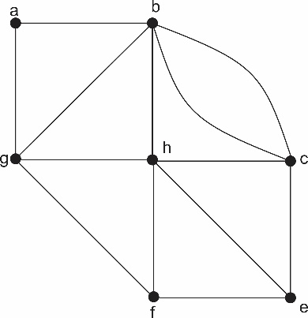

(CO2) [Comprehension]

9. Verify the graphs shown below are isomorphic or not.

|  |  |
| --- | --- |
|  |  |

(CO2) [Comprehension]

10. Prove that complete bipartite graph $K_{5}$ and $K_{3,3}$ are non planar graphs.(CO3) [Comprehension]

11. Define Chromatic number of a graph and find the chromatic number of the

following graph by assigning colors to the vertices.

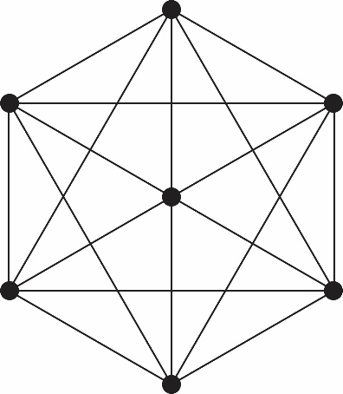

(CO3) [Comprehension]

12(a) Define binary search tree with example and form the binary search tree for the

following names Build a binary search tree for the word’s banana, peach, apple,

pear, coconut, mango, and papaya using alphabetical order

(b) Suppose that tree T has 3 vertices of degree 2, 4 vertices of degree 3 and 2

vertices of degree 4. Find the number of Pendant vertices in T. (CO4) [Comprehension]

**Part C [Problem Solving Questions]**

**Answer all the questions. 2Q x 15M = 30M**

13. Find the number of integer solution of the equation $x_{1}+x_{2}+x_{3}=20$ such that

$2≤x_{1}≤5$, $4≤x_{2}≤7$, $-2≤x_{3}≤9$. (CO1) [Application]

14. (a) Explain Krushkal’s algorithm.

(b) Apply Dijistra’s algorithm for the following graph to find shortest path

from u to v.

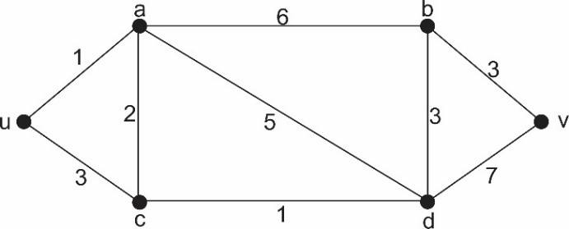

(CO5) [Application]