|  |  |  |  |  |  |  |  |  |  |  |  |
| --- | --- | --- | --- | --- | --- | --- | --- | --- | --- | --- | --- |
| Roll No |  |  |  |  |  |  |  |  |  |  |  |



**PRESIDENCY UNIVERSITY BENGALURU**

**SCHOOL OF DESIGN SET- B**

**END TERM EXAMINATION –MAY- JUNE 2024**

|  |  |
| --- | --- |
| **Semester :** Semester VI - 2021  **Course Code :** DES2118  **Course Name :** Estimation and Specifications  **Program :** B. Design | **Date :** Jun 12, 2024  **Time :** 1:00 PM - 4:00 PM  **Max Marks :** 100  **Weightage :** 50% |

**Instructions:**

1. *Read all questions carefully and answer accordingly.*
2. *Question paper consists of 3 parts.*
3. *Scientific and non-programmable calculator are permitted.*
4. *Do not write any information on the question paper other than Roll Number.*

*.*

**PART A**

**ANSWER ANY 5 QUESTIONS** **5QX6M=30M**

1. What is a detailed plan in any project? Describe its components and significance in ensuring projectsuccess.

(CO1) [Knowledge]

1. Name and describe four types of data required for preparing an estimate, explaining their relevance inaccurate cost assessment

(CO1) [Knowledge]

1. What is estimation? Briefly explain the need for estimation in construction projects, highlighting itsimportance in planning and resource management.

(CO1) [Knowledge]

1. How do architects and engineers ensure that project specifications meet industry standards andregulations?

(CO1) [Knowledge]

1. Define "Bill of Quantities" and discuss its purpose and importance in construction project management.(CO1) [Knowledge]
2. What are the common challenges faced in cost estimation and how can they be overcome? Discussstrategies to address these challenges

(CO1) [Knowledge]

1. State the purpose of analysis of rates and discuss how it helps in preparing accurate cost estimates forconstruction projects.

**PART B**

**ANSWER ANY 2 QUESTIONS** **2QX15M=30M**

(CO1) [Knowledge]

1. Explain the following terminologies: Work breakdown structure (WBS), Cost Breakdown structure(CBS), Basis of estimate (BOE).

(CO2) [Comprehension]

1. Explain 3 types of technical provisions in detail through examples.

(CO1) [Comprehension]

1. Cost of materials and Lead particulars given below. Calculate the cost of the materials at site usingtable.

a) Case 1

|  |  |  |  |  |  |
| --- | --- | --- | --- | --- | --- |
| No. Materials | Unit | Cost | Lead in km | Rate for lead/km | Handling charges |
| 1 Sand | 1 cub m | 115 | 6 | 4 | 14 |
| 2 Bricks | 1000 nos | 1785 | 11 | 6 | 20 |
| 3 Cement | 1 tonne | 7000 | 5 | 22 | 116 |
| b) Case 2 |  |  |  |  |  |
| No. Materials | Unit | Cost | Lead in km | Rate for lead/km | Handling charges |
| 1 Lime | cub m | 1075 | 4 | 10 | 54 |
| 2 Sand | cub m | 110 | 6 | 14 | 38 |
| 3 Surkhi | cub m | 400 | 4 | 10 | 54 |

(CO2) [Comprehension]

|  |  |  |
| --- | --- | --- |
|  | **PART C** |  |
|  | **ANSWER ANY 2 QUESTIONS** | **2QX20M=40M** |
| **11.** | Solve following problems. |  |

* 1. Prepare the rough estimate for a proposed commercial complexfor a municipal corporation for thefollowing data.

Plinth Area = 500m2/floor Ht of each storey = 3.5m No. of storey’s = G+2

Cubical content rate = Rs. 1000/m3

Provided for a following as a percentage of structured cost

water supply & Sanitary arrangement -8%

Electrification -6%

Fluctuation of rates - 5%

Contractors profit - 10%

Petty supervision & contingencies - 3%

* 1. Prepare an approximate estimate of building project with total plinth area of all building is 80 sqm.

and from following data.

Plinth area rate Rs. 40000 per sqm

Cost of water supply @7½%of cost of building.

Cost of Sanitary and Electrical installations each @ 7½% of cost ofbuilding.

Cost of architectural features @1% of building cost.

Cost of roads and lawns @5% of building cost.

Cost of P.S. and contingencies @4% of building cost. Determine the total cost of building project.

(CO3) [Application]

**12**. Prepare a detailed estimate of a part of a wall of a building from the given plan and section. Calculatefollowing.

* + 1. Brickwork in superstructure
    2. First class brickwork in foundation and plinth

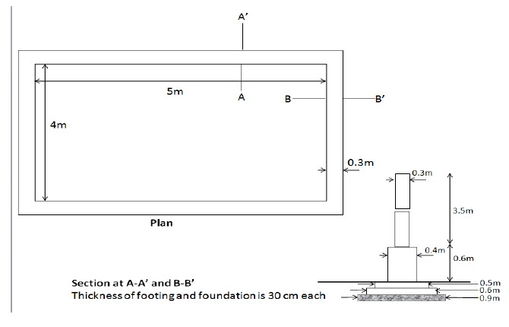

(CO3) [Application]

1. Write a detailed specification for a villa interior design project done in the previous semester forfollowing components. Provide sketches of plan & section. Assume necessary data.
   1. Flooring
   2. False ceiling
   3. Doors & windows
   4. Modular kitchen

(CO3) [Application]