|  |  |  |  |  |  |  |  |  |  |  |  |
| --- | --- | --- | --- | --- | --- | --- | --- | --- | --- | --- | --- |
| Roll No |  |  |  |  |  |  |  |  |  |  |  |



PRESIDENCY UNIVERSITY BENGALURU

**SET-A**

SCHOOL OF ENGINEERING

**END TERM EXAMINATION – MAY/JUNE 2024**

**Semester :** Semester VI - 2021

**Course Code :** ECE3042

**Course Name :**  MEMS and Nanotechnology

**Program :** B. Tech. Electronics and Communication Engineering

**Date :** June 19, 2024

**Time :** 1:00 PM - 4:00 PM

**Max Marks :** 100

**Weightage :** 50%

**Instructions:**

1. *Read all questions carefully and answer accordingly.*
2. *Question paper consists of 3 parts.*
3. *Scientific and non-programmable calculator are permitted.*
4. *Do not write any information on the question paper other than Roll Number.*

**PART A**

**ANSWER ANY FIVE QUESTIONS (5 Q X 2 M = 10 M)**

* 1. List any TWO differences between conventional micromachining and silicon micromachining

(CO1) [Knowledge]

* 1. Write the relationship between the output voltage and the applied pressure in the piezoelectric material

(CO1) [Knowledge]

* 1. In photolithography, if a negative photoresist is used, then the pattern obtained on the substrate will be

(same/different) as that of the photomask.

* 1. Match the electrical equivalent for each mechanical elements:
     1. Mass a. Resistance
     2. Stiffness b. Capacitance
     3. Damping c. Inductance

(CO2) [Knowledge]

(CO3) [Knowledge]

* 1. Define Insertion Loss associated with RF MEMS Switch, and what must be its ideal value of ?

(CO3) [Knowledge]

* 1. What is the critical gap (x), as a function of the distance of separation between two electrodes (d) of a parallel-plate capacitor so that the stability of the system is maintained?
  2. Identify the differences between self inductance and mutual inductance.

(CO4) [Knowledge] (CO4) [Knowledge]

**PART B**

**ANSWER ANY FIVE QUESTIONS (5 Q X 10 M = 50 M)**

* 1. What are the four components that constitute a MEMS System? Define transducers and justify how sensors and actuators can be two side of the coin.

(CO1) [Comprehension]

* 1. A research scholar in Presidency University is pursuing a project on developing pressure sensors. His work is to create a thin diaphragm of thickness 10 µm by bulk micromachining silicon substrate. The dimensions of the mask used is 500 µm x 500 µm. The thickness of the substrate is 200 µm. The etch rate of silicon is 500 nm/min and etch profile is anisotropic. The cross-sectional view of the diaphragm is shown.

1. Calculate the time needed to micromachine silicon to get the required diaphragm thickness
2. Find the dimensions of the diagpragm after bulk micromachining silicon
3. Find the minimum thickness of silicon dioxide (tox) required to micromaching silicon substrate if the etch selectivity between silicon and silicon dioxide is 100:1.

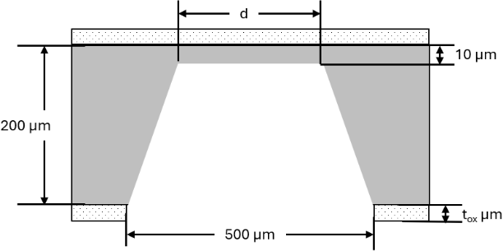

(CO2) [Comprehension]

* 1. Prof. Das from IIT Bombay developed a sensor to measure the pressure in mBar. The sensor will provide the output in the form of voltage in mV. On testing the sensor, the following calibration cure was obtained. From the calibration curve, find (i) Range, (ii) Sensitivity, (iii) Threshold, (iv) Offset and

1. Linearity.

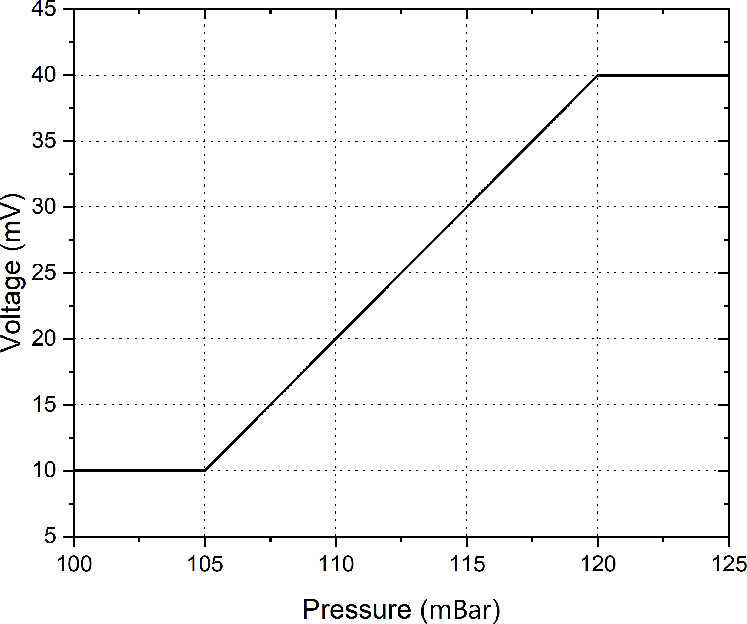

(CO2) [Comprehension]

1. As a consultant who is an expert in the field of MEMS switches, an executive engineer from Q&A International is seeking your perspective on the type of dielectric that can be used to design a switch that is power efficient. The idea of saving power is to bring down the pull-in voltage needed to actuate the switch. The switch is fabricated as a beam cantilever with dimensions 250 µm × 30µm and with spring constant (k) 260 N/m. The distance of separation between the electrodes is 50 µm. The permittivity of free space is 8.8E-12 F/m. The dielectrics of interest are air with relative permittivity 1, silicon dioxide with relative permittivity 3.9 and silicon nitride with relative permittivity 7. Compare and consult the engineer on the dielectric that saves more power.

(CO3) [Comprehension]

1. There are a few parameters that needs to be considered to develop a good RF MEMS device. Explain the following parameters and the ideal value that these parameters must have: (i) Transition time, (ii) Switching transient, (iii) Bandwidth (iv) Actuation voltage and (v) Series resistance

(CO3) [Comprehension]

1. Five students are doing their internship at the University of Manchester, England. They are tasked with fabricating a tunable MEMS capacitor with a tuning factor of 2. The fabricated capacitor is a simple fixed-fixed beam parallel plate capacitor. The professor has instructed to fabricate as many capacitors as possible on a single wafer. They students identified that the optimal dimensions (length × width) is 100 µm × 100 µm. They also identified that it is the best to use air as the dielectric. The permittivity of free-space is 8.8E-12 F/m and the relative permittivity of air is 1. With these limitations posed to the students, using your expertise in the field of MEMS, advise them on the thickness of the dielectric (spacing between the two electrodes).

(CO4) [Comprehension]

1. Intel is developing a new flagship processor that will execute instructions, with each instruction cycle having a time period of 41 ns. For this, an engineer suggested the use of RF MEMS Resonator due to its robust nature. For this, they used a comb-drive resonator whose beam thickness is 5 µm, width 5 µm and length 205 µm, having a stiffness coefficient of 400 N/m. In your opinion, comment on the movable mass that is required to achieve this operating frequency. Also, provide your perspective on the quality factor of the resonator if the Bandwidth at 3dB point is 48 MHz.

(CO4) [Comprehension]

**PART C**

**ANSWER ANY TWO QUESTIONS (2Q X 20 M = 40 M)**

1. (i) A blank silicon wafer is provided. Describe the steps (16 steps) required to get patterned Aluminum on the silicon wafer using lift-off process
   1. Write the processing steps in correct sequence to achieve the following pattern. (No diagrams necessary)

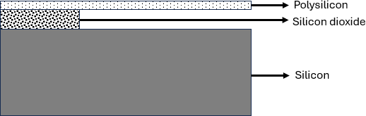

(CO2) [Application]

1. (i) Mention at least five advantages of using RF MEMS Switches over conventional Mechanical Switches
   1. Explain, with neat diagrams, the capacitive actuation principle to actuate a series contact RF MEMS Switch.

(CO3) [Application]

1. (i) Using diagrams, derive the tunig ratio of a 3-plate tunable MEMS capacitor and compare it with 2- plate capacitor
   1. What is the major disadvantage of a MEMS inductor, and show with diagram on how the problem is solved?

(CO4) [Application]