|  |  |  |  |  |  |  |  |  |  |  |  |
| --- | --- | --- | --- | --- | --- | --- | --- | --- | --- | --- | --- |
| Roll No |  |  |  |  |  |  |  |  |  |  |  |



PRESIDENCY UNIVERSITY BENGALURU

**SET-B**

SCHOOL OF ENGINEERING

**END TERM EXAMINATION – MAY/JUNE 2024**

**Semester :** Semester VI - 2021

**Course Code :** ECE3051

**Course Name :** - Machine Learning and Deep Learning Using FPGAs

**Program :** B. Tech. Electronics and Communication Engineering

**Date :** June 19, 2024

**Time :** 1:00 PM - 4:00 PM

**Max Marks :** 100

**Weightage :** 50%

# Instructions:

1. *Read all questions carefully and answer accordingly.*
2. *Question paper consists of 3 parts.*
3. *Scientific and non-programmable calculator are permitted.*
4. *Do not write any information on the question paper other than Roll Number.*

**PART A**

**ANSWER ANY THREE QUESTIONS (3 Q X 5 M = 15 M)**

1. The growing global population, changes in climate and dietary patterns, as well as increasing need for environmental protection have created an increasing demand for waste-free food production, deciding the category of potential food items e.g., edible or non-edible packages are needed. Implement the Mcculloch pitts model.

(CO3) [Knowledge]

1. Design and develop a Full Adder circuit using Behavioral-style modeling in VHDL to add three input bits (two binary digits and a carry bit) and produce two output bits (Sum and Carry)? Provide the VHDL code for this design.

(CO3) [Knowledge]

1. **Netflix** is at the forefront of streaming video compression. Just like Spotify, Netflix aims at a consistent experience and smooth playback. Because of that, their algorithm is more closely tied with the user. There is the initial setting of image quality, and then there is the quality of connection that regulates the compression methodology. Suggest suitable ANN algorithm for image compression.

(CO4) [Knowledge]

1. John carries an umbrella if it is sunny or if it is raining. There are four given situations. I need to decide when John will carry the umbrella. The situations are as follows:

First scenario: It is not raining, nor it is sunny

Second scenario: It is not raining, but it is sunny Third scenario: It is raining, and it is not sunny Fourth scenario: It is raining as well as it is sunny

Analyse the situations using the McCulloch-Pitts neural model,

(CO4) [Knowledge]

1. In Support Vector Machines (SVM), the concept of margins refers to the separation between the decision boundary and the closest data points. Discuss the Hard and Soft Margins with suitable examples

(CO1) [Knowledge]

**PART B**

**ANSWER ANY TWO QUESTIONS (2 Q X 20 M = 40 M)**

1. Decision Tree algorithm belongs to the family of supervised learning algorithms. Unlike other supervised learning algorithms, the decision tree algorithm can be used for solving regression and Classification problem too. The goal of using a Decision Tree is to create a training model that can use to predict the class or value of the target variable by **learning simple decision rules** inferred from prior data(training data).Develop a decision tree algorithm with suitable example using VHDL.

(CO3) [Comprehension]

1. Assume that the neurons have sigmoid activation function ,perform a forward pass and Backward pass on the network given.Assume that the actual output is 0.5 and the learning rate is 1

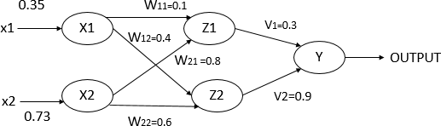

(CO4) [Comprehension]

1. Network bandwidth is a measurement indicating the maximum capacity of a wired or wireless communications link to transmit data over a network connection in a given amount of time.How does the design of a 4:1 MUX ensure efficient bandwidth utilization and maintain signal integrity within telecommunication networks? implement the 4:1 MUX using all three modeling styles of VHDL: behavioral, dataflow, and structural. Design 4:1 mux

(CO2) [Comprehension]

**PART C**

**ANSWER ANY THREE QUESTIONS (3 Q X 15 M = 45 M)**

1. Given the dataset, how can you systematically apply the decision tree algorithm to classify the data? Outline the steps involved in building the decision tree, including the calculation of entropy and information gain at each iteration.

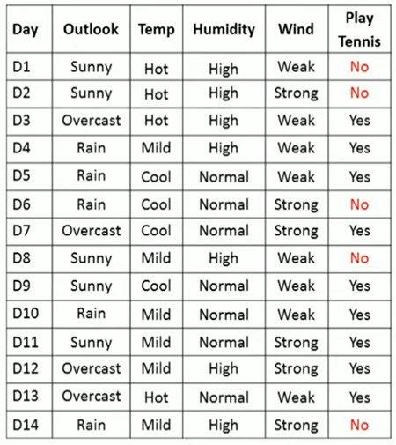

(CO4) [Application]

1. What is the significance of applying linear regression to a dataset comprising memory capacity and cost? Explain the linear regression process which help in understanding the relationship between these two features?

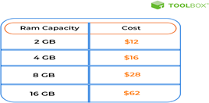

(CO2) [Application]

1. The perception model is a binary device, functioning in an all-or-nothing manner. It has multiple inputs and one output; if the combined inputs exceeded a certain threshold, the neuron would ‘fire’, otherwise, it remained inactive. Implement the three input Logical AND gate using Suitable perception model

(CO4) [Application]

1. Develop the VHDL code for the decision tree as given below

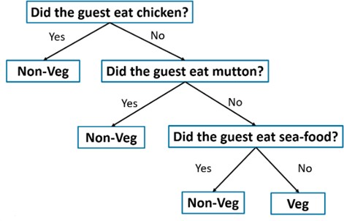

(CO2) [Application]