|  |  |  |  |  |  |  |  |  |  |  |  |
| --- | --- | --- | --- | --- | --- | --- | --- | --- | --- | --- | --- |
| Roll No |  |  |  |  |  |  |  |  |  |  |  |

PRESIDENCY UNIVERSITY BENGALURU

**SET-A**

SCHOOL OF ENGINEERING

**END TERM EXAMINATION – MAY/JUNE 2024**

**Semester :** Semester II - 2023

**Course Code :** EEE2015

**Course Name :** - Digital Electronics

**Program :** B.Tech.

**Date :** June 18, 2024

**Time :** 1:00 PM - 4:00 PM

# Max Marks : 100

**Weightage :** 50%

# Instructions:

1. *Read all questions carefully and answer accordingly.*
2. *Question paper consists of 3 parts.*
3. *Scientific and non-programmable calculator are permitted.*
4. *Do not write any information on the question paper other than Roll Number.*

**Part - A**

**Answer any 5 questions 5 x 4M= 20M**

**1.** Convert the following 1110110010111(2) = -------------(8) = ------------(16) = (10)

15B = ----------(8) = -------------(2) = (10) .

(CO1) [Knowledge]

1. Boolean algebra is a branch of mathematics that deals with operations on logical values with binary variables. Simplify the given logic expression using Boolean algebra

F(X, Y, Z) = X′Y + YZ′ + YZ + XY′Z′

(CO2) [Knowledge]

1. A full subtractor is a combinational circuit that performs subtraction involving three bits, namely A (minuend), B (subtrahend), and Bin (borrow-in). Implement a circuit to subtract 3 binary numbers and draw the nand gate circuit for the same.

(CO3) [Knowledge]

1. Code converter is a logic circuit whose inputs are bit patterns representing numbers (or character) in one cod and whose outputs are the corresponding representation in a different code. Write a truth table circuit and equation for binary code to gray code converter

(CO4,CO5) [Knowledge]

1. Sometimes the boolean expression may contain some missing varianbles. Hence the expression has to standardized. Express the given expression in the canonical POS form



(CO4) [Knowledge]

1. Latches or flipflops are used as basic building blocks in sequential circuits. Diffrentiate between latch and Flip flop

(CO5) [Knowledge]

1. All logic circuits are built using universal or basic gates. What is the output expression for circuit shown?

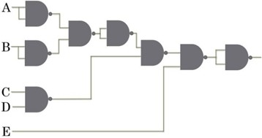

(CO1) [Knowledge]

**Part - B**

**Answer any 4 questions 4 x 10M = 40M**

1. The shifter circuit shifts the bits of an input vector by one bit position to the right. It fills the vacated bit on the left side with 0. With a relevant circuits explain all the operations of the shift register circuit

(CO1) [Comprehension]

1. Kmaps are graphical representation of the truth table. Use a Karnaugh map to find the minimal sum of products expression for the following logic functions: (Note: ‘d’ denotes the don’t care set.)

All 4-bit values with an odd number of 1s, and you don’t care about numbers divisible by 4 or 5. Draw the circuit using NAND gates.

(CO2,CO3) [Comprehension]

1. Derive the Boolean expression for outputs T1 to T3 and Y

List the truth table for the inputs ABC and determine the corresponding output

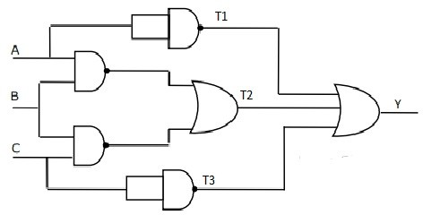

(CO2,CO3) [Comprehension]

1. The inputs to a circuit are the 4 bits of the binary number D3D2D1D0 .The circuit produces a 1 if and only if all of the following conditions hold.
   1. MSB is ‘1’ or any of the other bits are a ‘0’.
   2. D2 is a 1 or any of the other bits are a ‘0’.
   3. Any of the 4 bits are a 0

derive the minimized expression using K-map

(CO1,CO3) [Comprehension]

1. A multiplexer is a combinational circuit that has 2n input lines and a single output line. The multiplexer, shortened to “MUX” or “MPX”, is a combinational logic circuit
2. How many select lines does a 32 : 1 MUX need?
3. Given SOP function f(A, B, C) = m(0, 1, 4, 6, 7) . Use an 4:1 MUX to implement it
4. Implementing 16:1 Multiplexer using 4:1 Multiplexers

(CO4,CO5) [Comprehension]

1. Combinational logic is used to build circuits that produce specified outputs from certain inputs. The construction of combinational logic is generally done using one of two methods: a sum of products, or a product of sums. Implement the logic of a full adder, using a 3:8 decoder and OR gates.

Write the truth table and the logic expression for the Full Adder

(CO4,CO5) [Comprehension]

**Part - C**

**Answer any 2 questions 2 x 20M = 40M**

1. Counters are digital circuits which work in a sequence. Design synchronous counter for sequence: 0

→ 1 → 3 → 4 → 5 → 7 → 0, using T flip-flop.

(CO4,CO5) [Application]

1. Counter can perform upcounting or down counting operation depending on the cicuit used . Design a MOD 5 Asynchronous up counter using T flipflop.

(CO5,CO4) [Application]

1. Flip Flops are used to build memory devices since they can store data. Convert SR flipflop to D flip flop

(CO5,CO4) [Application]