|  |  |  |  |  |  |  |  |  |  |  |  |
| --- | --- | --- | --- | --- | --- | --- | --- | --- | --- | --- | --- |
| Roll No |  |  |  |  |  |  |  |  |  |  |  |

PRESIDENCY UNIVERSITY BENGALURU

**SET-B**

SCHOOL OF ENGINEERING

**END TERM EXAMINATION – MAY/JUNE 2024**

**Semester :** Semester VI - 2021

**Course Code :** EEE3002

**Course Name :** - Power System Analysis

**Program :** B. Tech.

**Date :** June 10, 2024

**Time :** 1:00 PM - 4:00 PM

**Max Marks :** 100

**Weightage :** 50%

**Instructions:**

1. *Read all questions carefully and answer accordingly.*
2. *Question paper consists of 3 parts.*
3. *Scientific and non-programmable calculator are permitted.*
4. *Do not write any information on the question paper other than Roll Number.*

**Part - A**

**Answer any 5 questions 5 x 4M= 20M**

* 1. 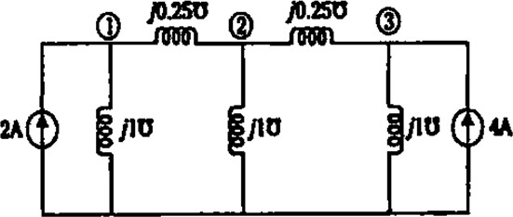In a power system, power is injected into a bus from generators, while the loads are tapped from it. There may be some buses with only generators, and others with only loads. Some buses have both generators and loads, while others may have static capacitors for reactive power compensation. The surplus power at some of the buses is transported through transmission lines to the buses deficient in power. To compute the load flow solution of the network, it is necessary to estimate the admittance value of the given power system network shown in Fig 1. Suggest a suitable method to compute the YBus matrix for the given power system network, mention the various methods, and compute the YBus for the given system with a suitable method.

Fig.1

(CO1) [Knowledge]

* 1. For each type of bus, list the specified quantites and the quantities that will be determined by the load flow analysis.

(CO2) [Knowledge]

* 1. What does a symmetrical component mean? Enumerate the symmetrical components and their relative significance.

(CO3) [Knowledge]

* 1. Define the power angle curve in power system stability analysis and list the key characteristics of the power-angle curve.
  2. List the important need for contingency analysis in the power system.

(CO4) [Knowledge]

(CO5) [Knowledge]

* 1. Define the term power system stability. Depending upon the nature and magnitude of the disturbance how the stability studies can be classified?

(CO4) [Knowledge]

* 1. List the power system contingency analysis key criteria to carry out the contingency analysis.

(CO5) [Knowledge]

**Part - B**

**Answer any 4 questions 4 x 10M = 40M**

* 1. Construct the single-line diagram for the system using the data given in Table No. 1, and calculate the voltage magnitude at each bus during the first iteration using the Gauss-Seidel (GS) method.

Table No. 1

|  |  |  |  |
| --- | --- | --- | --- |
| Starting Bus | Ending Bus | Resistance in pu | Reactance in pu |
| 1 | 2 | 0.05 | 0.15 |
| 1 | 4 | 0.10 | 0.30 |
| 2 | 3 | 0.15 | 0.45 |
| 2 | 4 | 0.10 | 0.30 |
| 3 | 4 | 0.05 | 0.15 |

(CO2) [Comprehension]

* 1. Obtain expression for the complex power transmitted over the transmission line for the system. if 

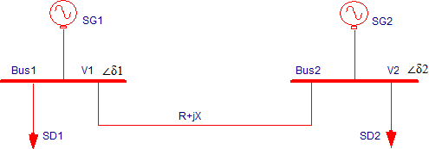=16, , .

(CO2) [Comprehension]

* 1. On the network of the power system that is now being used to carry electricity from Mysuru to Bengaluru, Mr. Kiran wants to conduct a contingency analysis. Contingency analysis in power systems replicates single equipment failure events (e.g., a single unit or line failing) or numerous equipment failure events (e.g., a number of units, lines, or their combination failing) one after the other until all "credible outages" are assessed. Explain the process that needs to be followed, along with the applicable flow chart, to implement the contingency plan.

(CO5) [Comprehension]

* 1. In this system, power is transmitted from Yelhanka's 100 MW gas power plant to KGF. The system includes a generator, a transmission line, a transformer, and two loads. A steady-state study is needed to determine how power flows through the system under specific operating conditions. As the electrical head of the project, suggest to Mr. Thanish, the NTPC manager, the various types of load analysis methods that can be used for this study. Additionally, provide a brief discussion on one of the computational procedures for computing the load flow solution using a simple system as an example.

(CO2) [Comprehension]

* 1. As power systems develop with the increasing interconnection of producing stations and load centers, one of the most essential tasks in the operation of power systems is to ensure that synchronization is maintained between the many components that make up the power system. Analyzing the electromechanical dynamic behavior of the prime mover-generator-excitation systems, various types of motors, and other types of loads with widely varied dynamic characteristics is possible via the use of methodologies that are somewhat oversimplified in order to better comprehend the processes that are at play. Explain about the many assumptions that are typically used during transient stability investigations

(CO4) [Comprehension]

* 1. Mr. George would like to perform a Contingency analysis on the power system network that is now being used to transfer power from Mysuru to Bengaluru. The contingency analysis in power systems models single failure events (i.e., one-line outages or one unit outages) or multiple equipment failure events (failure of multiple units or lines or their combination) one after another until all "credible outages" are considered. Describe the procedure to carry out the contingency process with the necessary flow chart.

(CO5) [Comprehension]

**Part - C**

**Answer any 2 questions 2 x 20M = 40M**

* 1. For the power system shown in Fig.2, the specification of the components are the following; G1: 25 kV, 100 MVA, X=9%.

G2: 25 kV, 100 MVA, X=9%.

T2: 25kV/220 kV, 90 MVA, X=12%. T2: 220kV/25 kV, 90 MVA, X=12%.

Line 220 kV, X=150 ohm.

Choose 25 kV as the base voltage at the generator G1, & 200 MVA as the MVA base. Draw the impedance diagram & per unit diagram.

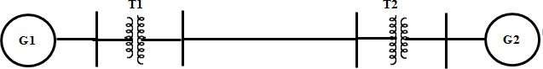

Fig.2

(CO1) [Application]

* 1. A 20 MVA, 13.8 kV generator has a direct axis sub transient reactance of 0.25 pu. Its negative sequence reactance is 0.35 pu, and its zero sequence reactance is 0.1 pu. The neutral of the generator is grounded. Compute the fault current, line-to-ground voltage, and line-to-line voltages for a single line-to-ground fault

(CO3) [Application]

* 1. The 0.25 pu is the direct axis subtransient reactance of a generator with a rating of 20 MVA and 13.8 kV. It has a zero-sequence reactance of 0.1 pu and a negative-sequence reactance of 0.35 pu. The generator's neutral terminal has been connected to ground. When there is a single line-to-ground fault, estimate the fault current, the line-to-ground voltage, and the line-to-line voltages

(CO3) [Application]