|  |  |  |  |  |  |  |  |  |  |  |  |
| --- | --- | --- | --- | --- | --- | --- | --- | --- | --- | --- | --- |
| Roll No |  |  |  |  |  |  |  |  |  |  |  |

PRESIDENCY UNIVERSITY BENGALURU

**SET-A**

SCHOOL OF ENGINEERING

**END TERM EXAMINATION – MAY/JUNE 2024**

**Semester :** Semester VI - 2021

**Course Code :** EEE3003

**Course Name :** Switchgear and Protection

**Program :** B.Tech.

**Date :** June 12, 2024

**Time :** 1:00 PM - 4:00 PM

# Max Marks : 100

**Weightage :** 50%

# Instructions:

1. *Read all questions carefully and answer accordingly.*
2. *Question paper consists of 3 parts.*
3. *Scientific and non-programmable calculator are permitted.*
4. *Do not write any information on the question paper other than Roll Number.*

**Part - A**

**Answer any 5 questions 5 x 4M= 20M**

1. Using examples such as open-type, semi-enclosed re-wirable, D-type cartridge, and HRC fuses, please explain how each type of fuse works. You should talk about how they are made, how they work, and where they are used in electrical setups. Outline the benefits and drawbacks of each type of fuse and provide a comparative analysis.

(CO1) [Knowledge]

1. Recall the role of auxillary switchgear and principal switchgear in power system protection

(CO1) [Knowledge]

1. Summarize an overview of how SF6 circuit breakers work and what makes them better than others.

(CO2) [Knowledge]

1. Recall the basic operation of vacuum circuit breakers.

(CO2) [Knowledge]

1. Using protected relaying as an example, describe the Plug Setting Multiplier (PSM). Explain the calculation of PSM and its importance in defining the operating characteristics of the relay. Give some instances that show how protective relaying techniques use PSM.

(CO3) [Knowledge]

1. Explain the key characteristics and parameters used in protective relaying. Provide examples of how these parameters are utilized in different protection schemes

(CO4) [Knowledge]

1. State the concept of impedance-based protection and its advantages over other types of relaying techniques. Summarize examples of situations where impedance-based protection is commonly employed.

(CO4) [Knowledge]

**Part - B**

**Answer any 4 questions 4 x 10M = 40M**

1. The phase to ground capacitance in a 132 kV transmission line is 0.01 microfarad. The value of inductance is 6H. Determine the voltage across the pole of a circuit breaker when a magnetizing current of 10A is abruptly stopped.The air blast circuit breaker is a three-phase device with a rating of 2500A, 1000MVA, operating at 33 kV for a duration of 3 seconds.

Calculate the following: (i) The current at which the device is designed to operate normally. (ii) The maximum current that the device can safely interrupt without causing damage. (iii) The maximum current that the device can safely handle under symmetrical conditions. (iv) The maximum current that the device can safely handle during the initial connection. (v) The voltage at which the device is designed to operate normally. (vi) Transient rating of circuit breaker

(CO1) [Comprehension]

1. The notion of Current Setting in protective relaying refers to the predetermined amount of current at which the relay is designed to operate. It plays a crucial role in setting the operational characteristics of the relay. The Current Setting is modified depending on several system parameters, including fault current levels, load conditions, and coordination requirements. By considering these factors, the Current Setting may be optimized to ensure that the relay operates reliably and effectively in detecting and responding to faults. Summarize some examples to demonstrate how to determine the Current Setting in various types of protective relaying schemes.

(CO2) [Comprehension]

1. The arc is sustained between the contacts of the circuit breaker due to the flowing of the current through the circuit breaker. The arc itself a conductive path of electricity and for total interruption of current, the circuit breaker is required to quench the arc as quick as possible. The main designing criteria of a circuit breaker is to provide appropriate technology of arc quenching in circuit breaker to fulfill quick and safe current interruption. The figure shown below represents this arc extinction theory. Identify the operating principle of extingishing the arc as depicted in the figure and stae one circuit breaker with proper diagram which can effectively perform this operation with minimum restriking of the arc.

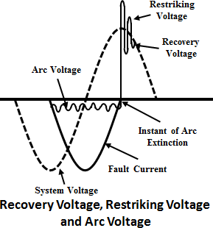

(CO2) [Comprehension]

1. The Plug Setting Multiplier (PSM) is a concept used in protective relaying to determine the sensitivity of a relay to detect faults. It is a numerical value that is multiplied by the relay's current setting to establish the threshold at which the relay will trip and initiate protective actions. Examine the calculation process of PSM (Pickup Setting Multiplier) and its importance in determining the operational parameters of a relay. Offer instances to demonstrate the utilization of PSM in protective relaying methods.

(CO3) [Comprehension]

1. 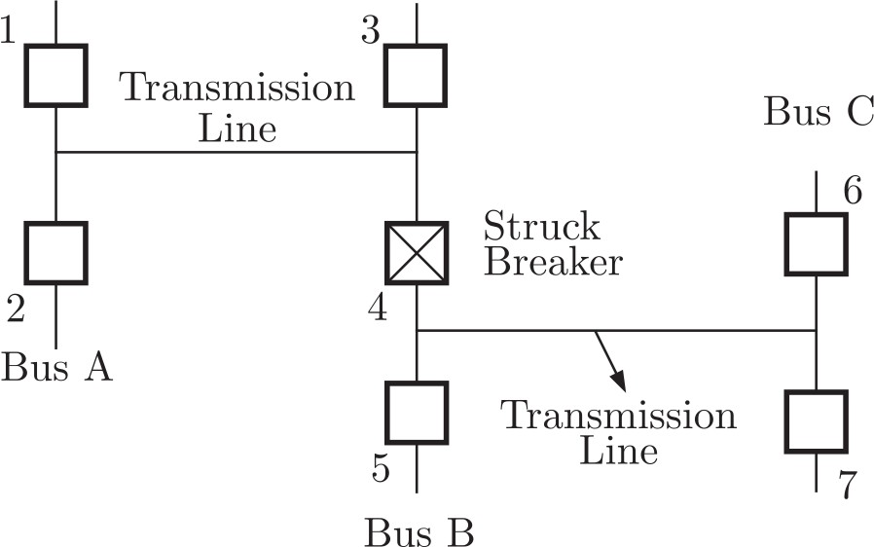Consider the protection system shown in the figure below. The circuit breakers numbered from 1 to 7 are of identical type. A single line to ground fault with zero fault impedance occurs at the midpoint of the line (at point F), but circuit breaker 4 fails to operate (‘‘Stuck breaker’’). If the relays are coordinated correctly, Interpret a valid sequence of operation of circuit breakers out of the following operations (A) 1, 2, 6, 7, 3, 5 (B) 1, 2, 5, 5, 7, 3 (C) 5, 6, 7, 3, 1, 2 (D) 5, 1, 2, 3, 6, 7 by providing a proper explanation.

(CO4) [Comprehension]

1. Examine the significance of accurate fuse selection in electrical installations. When choosing a fuse, it is important to take into account several criteria, including the current rating, voltage rating, and application requirements. Offer instances to demonstrate the repercussions of incorrect fuse selection and its potential effects on the safety and dependability of an electrical system.

(CO5) [Comprehension]

**Part - C**

**Answer any 2 questions 2 x 20M = 40M**

1. Consider a power system consisting of a transmission line protected by three distance relays located at different locations along the line. The line impedance is Z=0.4+j0.8 ohms per kilometer. The relays are set to operate for a reach of 80% of the line impedance. The line is 100 km long, and the fault occurs at a distance of 60 km from the source end. (Assume a fault clearing time of 0.1 seconds and a relay time delay of 0.05 seconds).
   1. Identify the unknown quantities that could be computed from the given data
   2. Compute the unknown parameters

(CO1) [Application]

1. 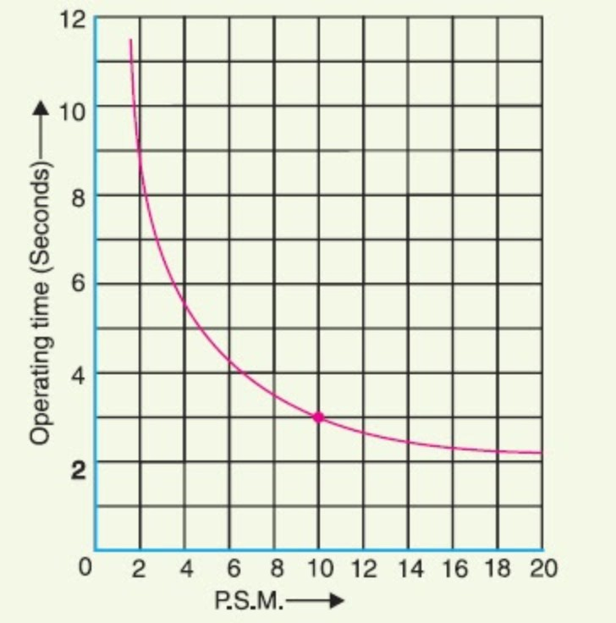The circuit breaker is fitted with a 600/5 A current transformer (C.T.) that is linked to an induction-type overcurrent relay. The relays are configured with a plug setting of 120% and a time setting of 0.6. Given a three-phase fault current of 8000 A flowing from a current transformer (C.T.) and relays following the provided characteristics curve at a time multiplier setting (TMS) of 1.
2. Identify the unknown parameters that could be computed from the given data
3. Compute the unknown parameters

(CO1) [Application]

1. The Table provides the time-current (PSM) characteristic of an overcurrent relay for a TMS of 1. Given that the current plug setting is set at 50% and the time multiplier is set at 0.75. The fault current is 3000 A and the relay is connected to a current transformer (CT) ratio of 400/5.
2. Identify the unknown quantities that could be computed from the given data
3. Conmpute the unknown quantities

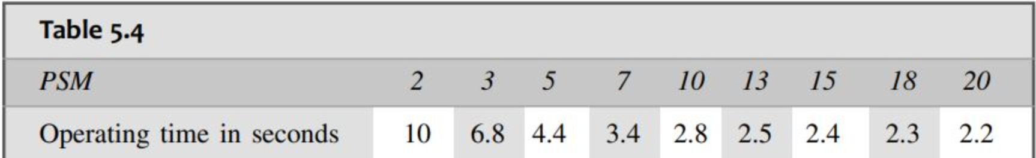

(CO5) [Application]