|  |  |  |  |  |  |  |  |  |  |  |  |
| --- | --- | --- | --- | --- | --- | --- | --- | --- | --- | --- | --- |
| Roll No |  |  |  |  |  |  |  |  |  |  |  |



PRESIDENCY UNIVERSITY BENGALURU

**SET-A**

SCHOOL OF ENGINEERING

**END TERM EXAMINATION – MAY/JUNE 2024**

**Semester :** Semester VI - 2021

**Course Code :** EEE3010

**Course Name :** Electrical Estimation and Costing

**Program :** B. Tech.

**Date :** June 14, 2024

**Time :** 1:00 PM - 4:00 PM

# Max Marks : 100

**Weightage :** 50%

# Instructions:

1. *Read all questions carefully and answer accordingly.*
2. *Question paper consists of 3 parts.*
3. *Scientific and non-programmable calculator are permitted.*
4. *Do not write any information on the question paper other than Roll Number.*

**Part - A**

**Answer any 5 questions 5 x 4M= 20M**

1. Electrical engineering diagrams are categorized based on their usage and the way they are represented. Identify that diagrams and their associated standards for any one application.

(CO1) [Knowledge]

1. State the key differences between single-phase and three-phase wiring estimation for small commercial buildings?

(CO2) [Knowledge]

1. State different types of lighting arrangement. Also state the factors affecting lighting scheme.

(CO3) [Knowledge]

1. It is a usual practice to show the various elements of a sub-station by their graphic symbols in the connection schemes. Outline any 6 symbols of equipment used in Sub-Stations.
2. Describe about Power Quality Analyzer. Also state the features of it.

(CO4) [Knowledge]

(CO5) [Knowledge]

1. Outline the steps involved in electrical design and estimation for a high-rise building.

(CO2) [Knowledge]

1. Define the following terms associated with lighting system: a. Reduction factor b. Maintenance factor

(CO3) [Knowledge]

**Part - B**

**Answer any 4 questions 4 x 10M = 40M**

1. A lineman's responsibilities include inspecting and repairing power lines as needed, and installing electricity meters at residential homes and buildings based on the approved building plan. Suppose a lineman is unable to provide the connection. As an electrical expert, Employ your skills by providing a neat sketch of the wiring layout from the supplier's pole to the distribution board of a consumer taking a single-phase supply.

(CO1) [Comprehension]

1. As a wiring installation engineer, you have been tasked with training a new team member in installation procedures. It is crucial to ensure that they are well-versed in the foundational guidelines that will serve as the basis for their understanding and execution of wiring installations. To this end, predict the key principles and best practices that should be conveyed at the initial step of their training.

(CO1) [Comprehension]

1. Flood lighting is a crucial aspect of both architectural aesthetics and functional illumination, often used to enhance the visibility and appeal of buildings, landscapes, and sports arenas during nighttime. Classify the flood light types based on luminous intensity, beam spread angle, mounting options and comapre the characteristics of them.

(CO3) [Comprehension]

1. Sketch the layout and components of a 16MVA, 110/11kV outdoor substation, and interpret the considerations for selecting HV and EHV power and distribution transformers.

(CO4) [Comprehension]

1. Summarize an electrical energy audit, and predict the key steps involved in conducting one for an industrial facility?

(CO5) [Comprehension]

1. Interpret the role of energy conservation in the industrial sector and choose the key areas where significant energy savings can be achieved.

(CO5) [Comprehension]

**Part - C**

**Answer any 2 questions 2 x 20M = 40M**

1. The ground floor plan of 39 x 20 m newly constructed two-story school building is shown in below figure(Even first floor also same as ground floor). The arrangement of lamps, fans, plugs and sockets, switch fuses, and other components in the installation plan are given. Draw a wiring diagram for ground floor showing the distribution of power to various points from the 3-phase, 4-wire supply. Estimate the quantity of materials required and the cost for the electrical installation including sub circuits(Assume any necessary data).

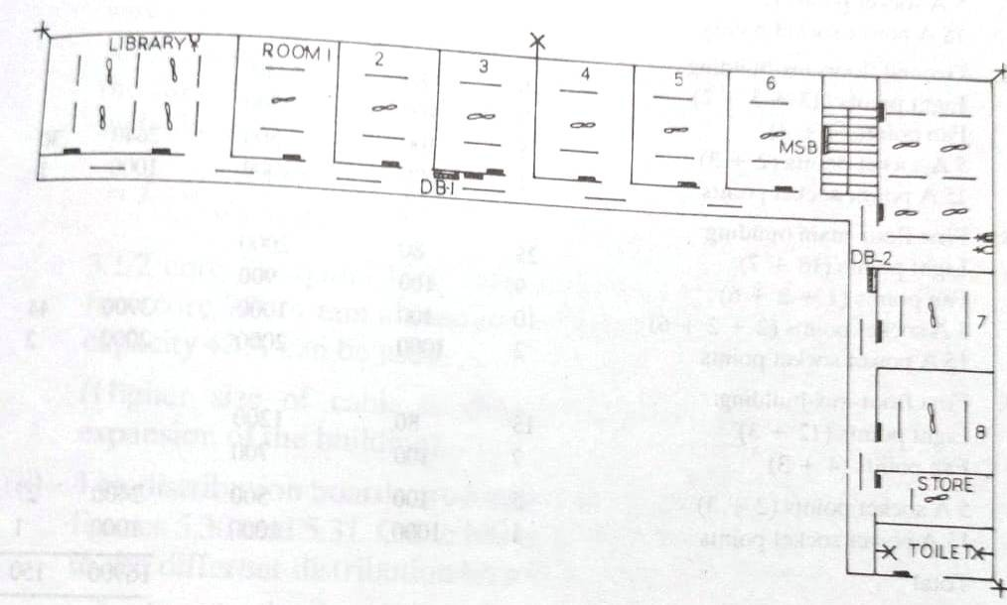

(CO2) [Application]

1. a. Two sources of candle power or luminous intensity 300 candela and 350 candela are mounted at

10 and 13 m, respectively. The horizontal distance between the lamp posts is 60 m (i) Identify different illumination points where the illumination can be measured. (ii). Calculate the illumination at the stated points of(i).

b. As an electrical engineer you are tasked with designing a street lighting scheme for a newly constructed suburban road. The road is 300 meters long and has a width of 15 meters. The required illuminance level is 40 lux, and you've decided to use LED luminaires with a luminous efficacy of 140 lumens per watt. The mounting height of the luminaires will be 10 meters, and a uniformity ratio of

0.65 is desired. The maintenance factor is 0.85. Calculate the total luminous flux required, the number of luminaires needed, and the recommended pole spacing.Assume a utilization factor of 0.75.

(CO3) [Application]

1. As an Assistant Engineer tasked with installing a pole-mounted outdoor 11 kV/415 Volts substation for a residential area with a 90 kVA load:
   1. Determine the appropriate cable sizes, the quantity of cables needed, and the cost of materials required to connect the transformer to the distribution box.
   2. Identify and describe the various types of substations and clearly explain their specific applications.

(CO4) [Application]