|  |  |  |  |  |  |  |  |  |  |  |  |  |
| --- | --- | --- | --- | --- | --- | --- | --- | --- | --- | --- | --- | --- |
| Roll No |  |  |  |  |  |  |  |  |  |  |  |  |



**Presidency University**

**Bengaluru**

**School of Engineering SET-A**

**End-Term Examination, May/June 2024**

**Semester**: Semester VI-2021

**Course Code**: ENG1015

**Course Name**: Professional Communication Skills for Engineers

**Department:** Languages

**Date**: June-6-2024

**Time**: 1:00pm to 4.00pm

**Max Marks**: 100

**Weightage**: 50%

**Instructions:**

1. *Read all questions carefully and answer accordingly.*
2. *Do not write any matter on the question paper other than roll number.*

**Part A**

**Answer** **any TEN Questions. Each question carries 2 marks. (10Qx2M=20M)**

1. State any four ‘K’ silent words. (CO:1 Bloom’s Level: Knowledge)
2. List the four features of connected speech. (CO:1 Bloom’s Level: Knowledge)
3. Describe the format of a formal email in English. (CO:1 Bloom’s Level: Knowledge)
4. Enumerate any two benefits of extempore speech. (CO:1 Bloom’s Level: Knowledge)
5. Define patterns of organization in informative speech. (CO:1 Bloom’s Level: Knowledge)
6. Describe the key features of persuasive speech. (CO:1 Bloom’s Level: Knowledge)
7. Enlist any four phrases that you can use for introduction in a graph analysis. (CO:2 Bloom’s Level: Knowledge)
8. State the four features of note making. (CO:2 Bloom’s Level: Knowledge)
9. Describe the structure and format of a proposal. (CO:2 Bloom’s Level: Knowledge)
10. List any four types of report. (CO:2 Bloom’s Level: Knowledge)
11. State the importance of punctuation in report writing. (CO:2 Bloom’s Level: Knowledge)
12. Outline the format for report writing. (CO:2Bloom’s Level: Knowledge)

**Part B**

**Answer any Four Questions. Each question carries 10 marks. (4Qx10M=40M)**

1. Discuss the rules for writing formal emails in English. (CO:1 Bloom’s Level: Understand)
2. Explain in what way does extempore speech will benefit a student in the long-run.

(CO:1 Bloom’s Level: Understand)

15. Exemplify impromptu speaking tactics with suitable examples. (CO:1 Bloom’s Level: Understand)

16. Describe structure of a paragraph with ample examples. (CO:2 Bloom’s Level: Understand)

17. Extrapolate the need for style and organization in writing a paragraph.

(CO:2 Bloom’s Level: Understand)

18. Discuss the qualities or characteristics of good report. (CO:2 Bloom’s Level: Understand)

**Part C**

**Answer any Two Questions. Each question carries 20 marks. (2Qx20M=40M)**

19. Draft a speech on the given context: Imagine you are invited to give a speech on the importance of Communication skills in work place to first year undergraduate students in your university. (CO:1 Bloom’s Level: Apply)

20. Write a graph analysis for the pie chart provided below. The pie chart depicts the percentage of social media users by age in Jamestown in 2018.

(CO:2 Bloom’s Level: Analyze)

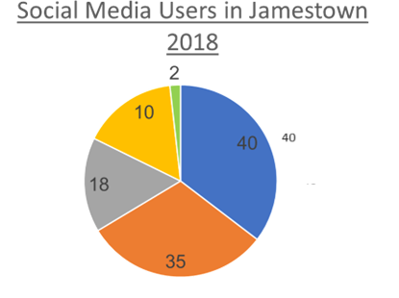

21. Prepare a proposal to your school to do a project on controlling environmental pollution, oil

spillage, and gas flaring. (CO:1 Bloom’s Level: Apply)