|  |  |  |  |  |  |  |  |  |  |  |  |
| --- | --- | --- | --- | --- | --- | --- | --- | --- | --- | --- | --- |
| Roll No |  |  |  |  |  |  |  |  |  |  |  |

PRESIDENCY UNIVERSITY BENGALURU

**SET-B**

SCHOOL OF ENGINEERING

**END TERM EXAMINATION – MAY/JUNE 2024**

**Semester :** Semester IV - 2022

**Course Code :** MEC2015

**Course Name :** Metrology and Mechanical Measurements

**Program :** B.Tech.

**Date :** June 12, 2024

**Time :** 9:30 AM 12:30PM

# Max Marks : 100

**Weightage :** 50%

# Instructions:

1. *Read all questions carefully and answer accordingly.*
2. *Question paper consists of 3 parts.*
3. *Scientific and non-programmable calculator are permitted.*
4. *Do not write any information on the question paper other than Roll Number.*

**PART A**

**ANSWER ANY FIVE QUESTIONS 5QX2M=10M**

1. Write the dimensions of the following LMC for a shaft. **LMC of Ø0.240±.005?** LMC for a hole. **LMC of Ø0.250±.005?**
2. Explain the principle behind a machine vision system used in metrology.
3. What is the difference between the pitch and lead of a screw thread?
4. Draw the possible outcomes of the following figure.

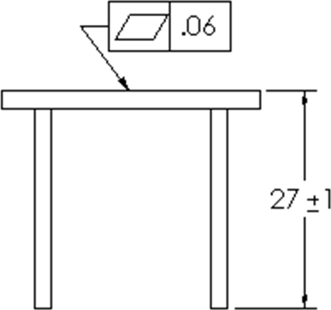

(CO3) [Knowledge] (CO4) [Knowledge] (CO5) [Knowledge]

(CO3) [Knowledge]

1. What is the purpose of using a Coordinate Measuring Machine (CMM) in metrology?

(CO4) [Knowledge]

1. What is the principle behind using the three-wire method for measuring the effective diameter of an external thread?

(CO5) [Knowledge]

1. Define the terms ‘addendum and dedendum’ in screw threads.

(CO2) [Knowledge]

**PART B**

**ANSWER ANY FIVE QUESTIONS 5QX10M=50M**

1. Explain the functional requirement of comparators and classify the same.

(CO1) [Comprehension]

1. Determine type of Fit of Basic size 75 hole basis system, hole being prepared by broaching and honing & shaft fit is s6.
2. List and explain the types of errors in gears.
3. Explain with a neat diagram MMC & LMC for hole and shaft.

(CO2) [Comprehension] (CO3) [Comprehension]

(CO4) [Comprehension]

1. Define Perpendicularity. Provide a detailed example using the feature control frame and datum for the following scenario.

Restrict the plane 1 & 2 to 0.005mm by assigning random dimension using orthographic views.

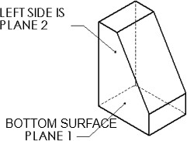

1. List and explain the types of errors in Threads.

(CO5) [Comprehension]

(CO3) [Comprehension]

1. Compare and contrast traditional dimensioning methods with GD&T, highlighting the advantages of using GD&T in engineering drawings.

(CO4) [Comprehension]

**PART C**

**ANSWER ANY TWO QUESTIONS 2QX20M=40M**

1. A manufacturing company is designing a precision assembly that requires a shaft and hole fit. The shaft, which has a basic size of 65 mm, will be prepared using broaching, rolling, and extrusion processes. The hole, which needs to be fitted around the shaft, will be manufactured using a capstan lathe and requires a G-type fit.
   1. **Determine the appropriate fit type and specify the tolerance limits for both the shaft and the hole in this shaft basis system.**
   2. **Create a tolerance diagram illustrating the fit.**

(CO2) [Application]

1. A manufacturing engineer is tasked with interpreting the tolerance requirements for a part based on a technical drawing. The drawing specifies a hole with certain geometric tolerances.
2. Show the tolerance table for the specified hole.
3. 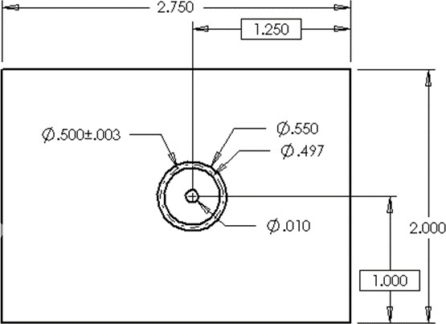Construct the corresponding tolerance zone diagrams for the hole.

(CO5) [Application]

1. A mechanical engineer is tasked with ensuring the correct orientation of various features on a machined part. The engineer needs to define and apply the concepts of angularity and parallelism to ensure precise geometric relationships between features.
2. Define angularity and parallelism in the context of geometric dimensioning and tolerancing (GD&T).
3. 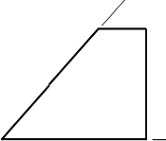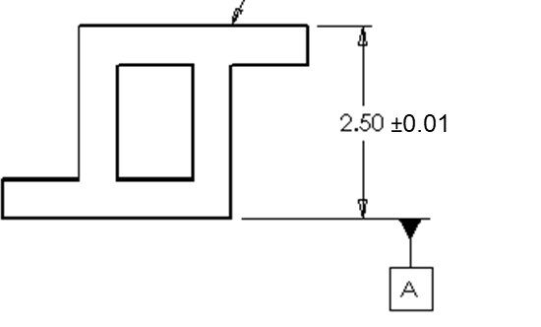Depict the application of angularity and parallelism using the feature control frame and datum for your assumed scenarios.

(CO4) [Application]