|  |  |  |  |  |  |  |  |  |  |  |  |
| --- | --- | --- | --- | --- | --- | --- | --- | --- | --- | --- | --- |
| Roll No |  |  |  |  |  |  |  |  |  |  |  |



PRESIDENCY UNIVERSITY BENGALURU

**SET-B**

SCHOOL OF ENGINEERING

**END TERM EXAMINATION – MAY/JUNE 2024**

**Semester :** Semester VI - 2021

**Course Code :** MEC3063

**Course Name :**  Control Engineering

**Program :** B. Tech.

**Date :** June 10, 2024

**Time :** 1:00 PM - 4:00 PM

# Max Marks : 100

**Weightage :** 50%

# Instructions:

1. *Read all questions carefully and answer accordingly.*
2. *Question paper consists of 3 parts.*
3. *Scientific and non-programmable calculator are permitted.*
4. *Do not write any information on the question paper other than Roll Number.*

**PART A**

**ANSWER ANY FIVE QUESTIONS 5QX2M=10**

1. Write two Applications of Open loop Control system.
2. What is the definition of Proportional Control Mode and write the equation for it.
3. Write the definition for Time Varying Systems & Time Invariant Systems

(CO1) [Knowledge] (CO1) [Knowledge] (CO1) [Knowledge]

1. Write all three elements of mechanical systems and three elements of electrical systems.

(CO2) [Knowledge]

1. In force-voltage analogy, write the analogous elements for Mass & Friction constant.

(CO2) [Knowledge]

1. As per Force-Current analogy, write the analogous elements for Displacement and Friction.

(CO2) [Knowledge]

1. What is signal flow graph? Write the definition of path gain.

(CO4) [Knowledge]

**PART B**

**ANSWER ANY FIVE QUESTIONS 5QX10M=50**

1. Explain the working of closed loop system with neat diagram. Also write the differences between linear and nonlinear control systems?

(CO1) [Comprehension]

1. What are servomotors and what are the requirements of a Good servomotor. Write the classification of servomotors?

(CO2) [Comprehension]

1. The block diagrams and signal flow graphs are widely used in analyzing the complex control systems. Write any 7 differences between Block Diagram and Signal Flow Graph.

(CO3) [Comprehension]

1. Write the steps involved in converting the block diagram into signal flow graphs. Also explain the Mason's gain formula used for finding overall transfer function of Signal flow graph.

(CO3) [Comprehension]

1. The block diagrams and signal flow graphs are widely used in analyzing the complex control systems. Write 8 differences between Block Diagram and Signal Flow Graph.

(CO4) [Comprehension]

1. Signal flow graphs are used in analyzing the control systems. Elucidate the procedure of converting block diagram into signal flow graph. Also explain the Mason's gain formula used to analyze the signal flow graph.

(CO4) [Comprehension]

1. Block diagrams reducing techniques are used for reducing the given block diagram for obtaining the overall transfer function of the control system.

Explain block diagram reducing rules for 1). Blocks connected in parallel 2). Shifting a summing point beyong the block

3). Shifting a takeoff point beyond the block

(CO3) [Comprehension]

**PART C**

**ANSWER ANY TWO QUESTIONS 2QX20M=40**

1. Reduce the given block diagram and find out the overall transfer function.

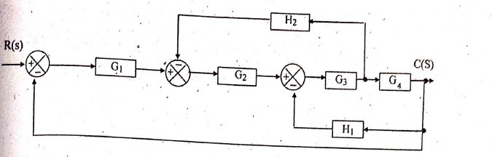

(CO3) [Application]

1. Find the overall transfer function of the system whose signal flow graph is shown below.

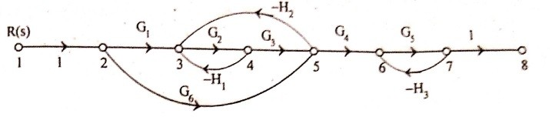

(CO4) [Application]

1. Reduce the given block diagram below and find out the overall transfer function.

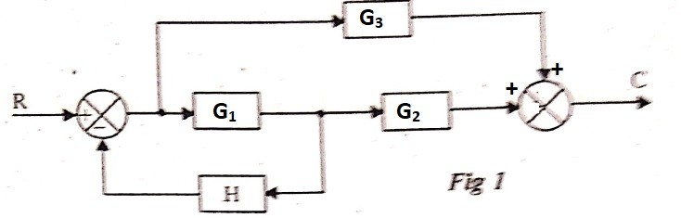

(CO3) [Application]