|  |  |  |  |  |  |  |  |  |  |  |  |
| --- | --- | --- | --- | --- | --- | --- | --- | --- | --- | --- | --- |
| Roll No |  |  |  |  |  |  |  |  |  |  |  |



PRESIDENCY UNIVERSITY BENGALURU

**SET-B**

SCHOOL OF ENGINEERING

**END TERM EXAMINATION – MAY/JUNE 2024**

**Semester :** Semester VI - 2021

**Course Code :** CIV3004_v02

**Course Name :** Design of Structural Steel Elements

**Program :** B. Tech. Civil Engineering

**Date :** June 12, 2024

**Time :** 1:00 PM - 4:00 PM

**Max Marks :** 100

**Weightage :** 50%

**Instructions:**

1. *Read all questions carefully and answer accordingly.*
2. *Question paper consists of 3 parts.*
3. *Scientific and non-programmable calculator are permitted.*
4. *Do not write any information on the question paper other than Roll Number.*

# PART A

## Answer any 4 4*5=20

* 1. Illustrate the types of bolted connections with figure.
  2. List the advantages and disadvantages of structural steel.

(CO1) [Knowledge] (CO1) [Knowledge]

* 1. Determine the strength of the welded joint if an 18mm thick plate is joined to a 16mm thick plate by a 200mm long butt weld when a) a double V butt weld is used b) a single V butt weld is used. Assume shop welding.

(CO2) [Knowledge]

* 1. Determine the design strength of joint, if welding is done as shown in Fig. A tie member in truss girder is 100mmx 12mm size. It is welded to a 12mm thick gusset plate by a fillet weld. The overlap of the member is 275mm and the weld size is 5mm. Assume site welding.

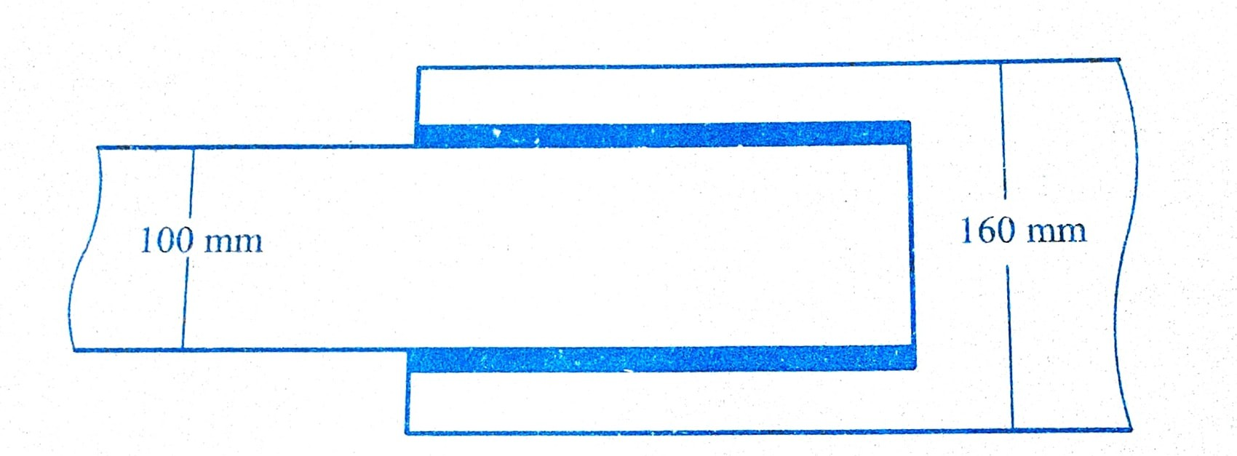

(CO2) [Knowledge]

* 1. Calculate the strength of a 20 mm diameter bolt of grade 4.6 for a single cover butt joint; the cover plate being 10 mm thick. The main plates to be jointed are 12 mm thick.
  2. What are the different types of column based on slenderness ratio?

(CO2) [Knowledge] (CO3) [Knowledge]

* 1. Determine the net section rupture strength of the tension member shown in figure. The steel is of grade Fe410.

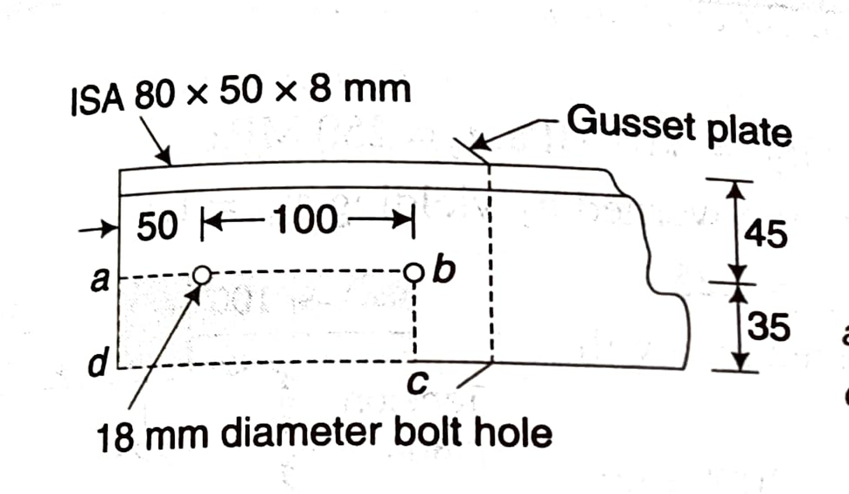

(CO3) [Knowledge]

* 1. Calculate the radius of gyration for a built-up column consisting of ISHB250 @54.7kg/m with one cover plate 300mm x 20mm on each flange.

(CO3) [Knowledge]

# PART B

## Answer any 4 4*10=40

* 1. What will be the efficiency of the lap joint as shown in figure. Use bolt of 16mm diameter and grade 4.6. Assume the grade of plate as Fe410.

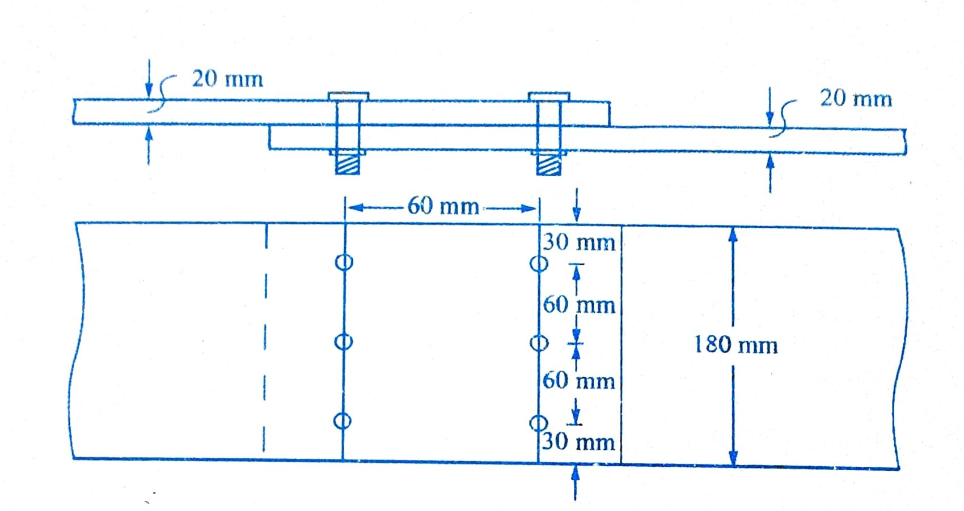

(CO2) [Comprehension]

* 1. Design a double cover butt joint to connect two plates each of width 100 mm, if the thickness of one plate is 12 mm and the other is 10 mm. The joint has to transfer a factored load of 100kN. The plates are of fe 410 grade. Use bearing type of bolts and draw connection details. Assume 8mm thick cover plate.

(CO2) [Comprehension]

* 1. Two plates of 12 mm and 10mm thickness are to be jointed by groove weld as shown in figure. The joint is subjected to a factored tensile force of 450 kN. The effective length of weld is restricted to 175mm only. Assume the plates to be shop welded. Check the safety of joint if a) Double U groove weld is provided. b) Single U groove weld is provided.

(CO2) [Comprehension]

* 1. A circular plate, 150mm diameter is welded to another plate by means of a 6mm fillet weld as shown in figure. Calculate the strength of fillet weld assuming Fe410 steel and shop welding.

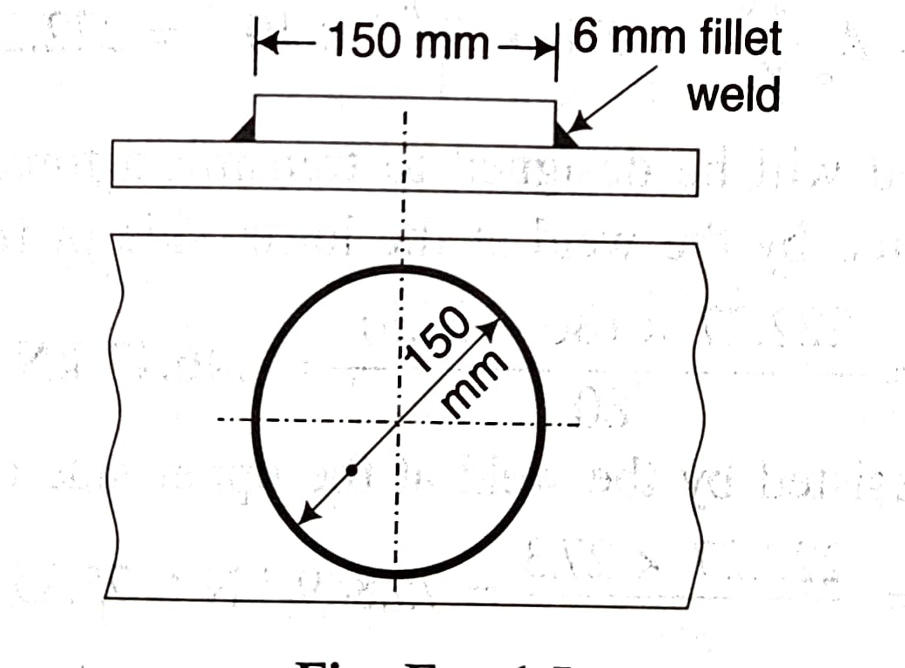

* 1. Explain the various modes of failure of a bolted connection.
  2. Explain the modes of failure of a compression member.

(CO2) [Comprehension] (CO1) [Comprehension] (CO3) [Comprehension]

# PART C

## Answer any 2 2*20=40

* 1. A single unequal angle ISA90x60x6 is connected to a 10mm thick gusset plate at the ends with five 16 mm dia bolts to transfer tension. Determine the design tensile strength of the angle if the gusset plate is connected to the shorter leg.

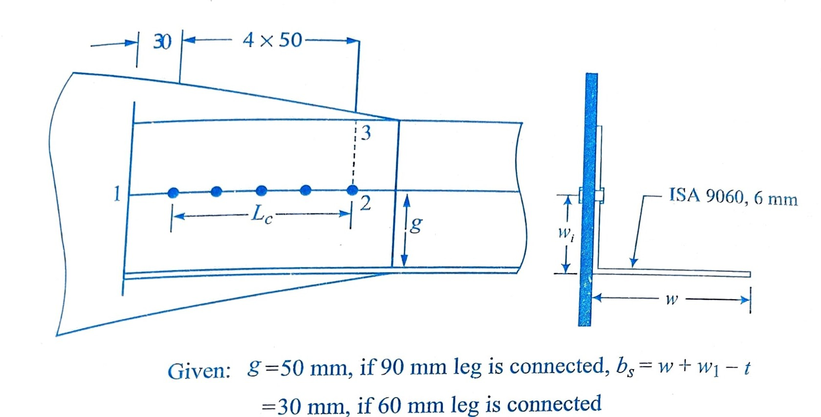

(CO3) [Application]

* 1. Design a bridge truss diagonal subjected to a factored tensile load of 300kN. The length of the diagonal is 3m. The tension member is connected to a gusset plate 16mm thick using fillet weld

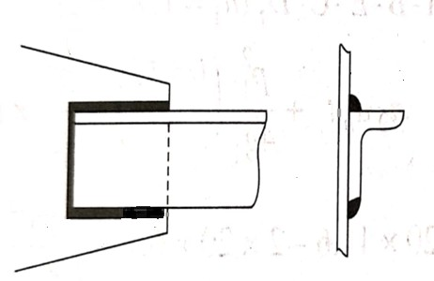

(CO3) [Application]

* 1. Determine the design axial load capacity of the column ISHB300 @ 58.8kg/m if the length of the column is 3m if both the ends translation is restrained but rotation is free. Will the capacity increase or decrease if both the ends are restrained against translation as well as rotation and by how much?

(CO3) [Application]

* 1. Design a single angle compression member to carry a factored load of 180kN. The effective length of the member is 2.55m.

(CO3) [Application]