|  |  |  |  |  |  |  |  |  |  |  |  |
| --- | --- | --- | --- | --- | --- | --- | --- | --- | --- | --- | --- |
| Roll No |  |  |  |  |  |  |  |  |  |  |  |

PRESIDENCY UNIVERSITY BENGALURU

**SET-B**

SCHOOL OF ENGINEERING

**END TERM EXAMINATION – MAY/JUNE 2024**

**Semester :** Semester IV - 2022

**Course Code :** MEC4003

**Course Name :** - Applied Thermodynamics

**Program :** B. Tech.

**Date :** June 19, 2024

**Time :** 9:30 AM - 12:30 PM

# Max Marks : 100

**Weightage :** 50%

# Instructions:

1. *Read all questions carefully and answer accordingly.*
2. *Question paper consists of 3 parts.*
3. *Scientific and non-programmable calculator are permitted.*
4. *Do not write any information on the question paper other than Roll Number.*

**PART A**

**ANSWER ANY FIVE QUESTIONS 5QX2M=10**

1. As the number of reheat stages in Rakine cycle are increased, the reheat process approaches

Process at maximum temperature. Write the T-S diagram for it.

1. Write P-V and T-S diagram for Carnot cycle.
2. Write the P-V and T-S diagrams for Rankine cycle.
3. Write the functions of air in gas turbine in Brayton cycle.
4. Write all 4 processes involved in Otto cycle.
5. Define compression ratio.
6. Write all 4 components (parts) used in Vapor Power Cycle or Rankine cycle?

(CO1) [Knowledge] (CO1) [Knowledge] (CO2) [Knowledge] (CO2) [Knowledge] (CO1) [Knowledge] (CO1) [Knowledge] (CO2) [Knowledge]

**PART B**

**ANSWER ANY FIVE QUESTIONS 5QX10M=50**

1. Explain Regenerative-Rankine cycle with block diagram. Use single open feed water heater in block diagram. Also plot T-S diagram.

(CO3) [Comprehension]

1. In the Rankine cycle for a steam power plant the turbine entry and exit enthalpies are 2803 kJ/kg and 1800 kJ/kg, respectively. The enthalpies of water at pump entry and exit are 121 kJ/kg and 124 kJ/kg respectively. Plot T-S diagram showing all points clearly and calculate the specific steam consumption (in kg/kWh) of the cycle.

(CO3) [Comprehension]

1. The inlet and the outlet conditions of steam for an adiabatic steam turbine are as indicated in the notations are as usually followed.
2. Calculate the power output of the turbine (in MW) assuming mass flow rate of steam through the turbine is 20 kg/s.

B) Assume the above turbine to be part of a simple Rankine cycle. The density of water at the inlet to the pump is 1000kg/ $m^{3}$. Ignoring kinetic and potential energy effects, Calculate the specific work (in kJ/kg) supplied to the pump.

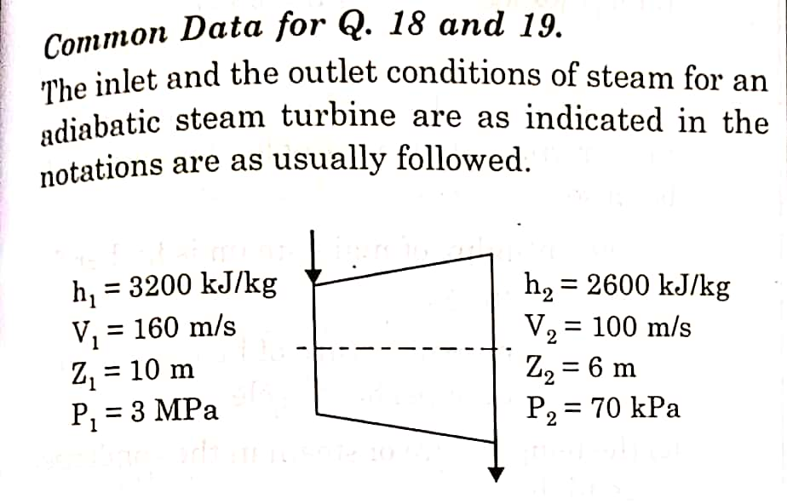

(CO3) [Comprehension]

**11.** Explain working of Reheat Rankine cycle with block diagram. Also plot P-V and T-S diagram clearly showing all points

(CO3) [Comprehension]

**12**. Write the principle of refrigeration and explain the refrigeration process with all 4 parts of it. Also calculate one ton of refrigeration in terms of kW. Write any 4 applications of refrigeration.

(CO3) [Comprehension]

**13.** Explain working of Rankine cycle with block diagram. Also plot P-V and T-S diagram.

(CO3) [Comprehension]

**14.** Explain the following effects on Refrigeration effect and work input to compressor for Vapor Compression Refrigeration System(VCRS) with the help of Pressure-Enthalpy Diagram.

* 1. When evaporator pressure decreases.
  2. When condensor pressure increases.
  3. When refrigerants are superheated after evaporator.

(CO3) [Comprehension]

**PART C**

**ANSWER ANY TWO QUESTIONS 2QX20M=40**

**15**.[A] In a Steam power plant based on rankine cycle, Steam is initially expanded in high pressure turbine. The steam is then reheated in a reheater and finally expanded in low pressure turbine. The expansion work in high pressure turbine is 400 kJ/kg and low pressure turbine is 850 kJ/kg where as pump work is 15 kJ/kg. If cycle efficiency is 32% then calculate the heat rejected in condenser(kJ/kg). Also plot T-S diagram showing all points. [10M]

[B] In a 5 kW cooling capacity refrigeration system operating on simple VCRS, the refrigerants enters the evaporator with enthalpy of 75 kJ/kg,and leaves with enthalpy of 183 kJ/kg. The enthalpy of refrigerant after compression is 210 kJ/kg. Then calculate- [10M]

1. Cofficient of Performance(COP)
2. Power input to compressor in kilowatts
3. Rate of heat transfer across condenser in kW.

(CO4) [Application]

**16.** [A] Consider a steam power plant operating on ideal reheat rankine cycle. The work input to pump is 20 kJ/kg. The work output from high pressure turbine is 750 kJ/kg.The work output from low pressure turbine is 1500 kJ/kg. The thermal efficiency of cycle is 50%. The enthalpy of saturated liquid and saturated vapour at condenser pressure are 200 kJ/kg and 2600 kJ/kg, respectively. calculate the quality of steam at the exit of the low pressure turbine. Also plot the cycle on T-S diagram showing all points clearly. [10M]

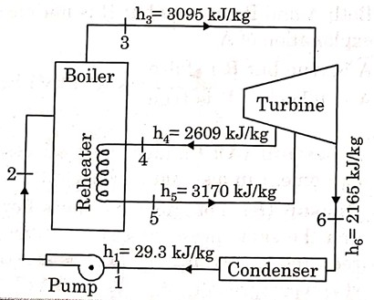[B] Consider a steam power plant using a reheat cycle as shown. Steam leaves the boiler and enters the turbine at 4MPa,350ºC(h3=3095kJ/kg). After expansion in the turbine to 400kPa(h4=2609kJ/kg), the steam is reheated to 350ºC(h5=3170kJ/kG), and then expanded in a low pressure turbine to 10kPa( h6=2165kJ.kg), the specific volume of liquid handle by the pump can be assumed to be v=0.0010025 /kg.

Calculate- [10M]

1. Thermal efficiency of cycle.
2. Enthalpy at the pump discharge(h2)

(CO4) [Application]

**17.** [A] An ideal Re-heat Rankine cycle operates between the pressure limits of 10 KPa and 8MPa, with reheat done at 4 MPa.The temperature of steam at the inlets of both turbines is 500ºC, and the enthalpy of steam is 3185 kJ/kg at the exit of high pressure turbine and 2247 kJ/kg at the exit of low pressure turbine. Disregrading the pump work, Calculate thermal efficiency of cycle and also plot T-S diagram showing all points clearly. [10M]

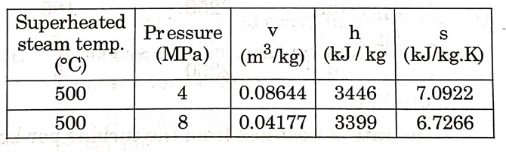

[B] Steam enters a well insulated turbine and expands isentropically throughout. At an intermediate pressure, 20 percent of the mass is extracted for process heating and the remaining steam expands isentropically to 9 kPa. Inlet to turbine: P = 14 MPa, T = 560°C,h = 3486 kJ/kg, s = 6.6 kJ/(kgK) Intermediate stage: h = 276 kJ/kg, Exit of turbine: P = 9 kPa, hf = 174 kJ/kg,hg = 2574 kJ/kg, sf = 0.6 kJ/(kgK), sg = 8.1 kJ/(kgK)

h=specific enthalpy, s= specific entropy, subscript f and g denotes saturated liquid and saturated vapor state.

If the flow rate of steam entering the turbine is 100 kg/s, then Calculate the work output (in MW) . Also plot T-S diagram showing steam extraction. [10M]

(CO4) [Application]