|  |  |  |  |  |  |  |  |  |  |  |  |
| --- | --- | --- | --- | --- | --- | --- | --- | --- | --- | --- | --- |
| Roll No |  |  |  |  |  |  |  |  |  |  |  |



PRESIDENCY UNIVERSITY BENGALURU

**SET-A**

SCHOOL OF ENGINEERING

**END TERM EXAMINATION – MAY/JUNE 2024**

**Semester :** Semester II - 2023

**Course Code :** PET1001

**Course Name :**  Petroleum Geology

**Program :** B. Tech. Petroleum Engineering

**Date :** June 18, 2024

**Time :** 1:00 PM - 400 PM

**Max Marks :** 100

**Weightage :** 50%

**Instructions:**

1. *Read all questions carefully and answer accordingly.*
2. *Question paper consists of 3 parts.*
3. *Scientific and non-programmable calculator are permitted.*
4. *Do not write any information on the question paper other than Roll Number.*

# PART A

**ANSWER ANY FIVE QUESTIONS 5QX2M=10M**

* 1. List out any two functions that any geomorphic agent serves in general.
  2. Fill in the Blanks:
     1. The difference between Equatorial Radius and Polar Radius is km.
     2. The Mean Radius of the Earth is km.

(CO1) [Knowledge]

(CO1) [Knowledge]

* 1. A few lithologies generally observed as cap rock are Salt, Anhydrite, Organic-rich Shales, Shales, Silty Shales, Calcareous Mudstones, and Cherts. Find out the most ductile and least ductile lithologies.

(CO2) [Knowledge]

* 1. Fill in the Blanks: The most ductile lithologies are evaporites. This may explain the extraordinary success of evaporites as cap rocks. Ductility is also a function of and . Evaporites may be brittle at shallow depths, but very ductile at depths of over 1km.

(CO2) [Knowledge]

* 1. Fill in the Blanks with the appropriate information: There are sedimentary basins in India, covering a total area of million square kilometers. The area is spread across onland, shallow water up to 400 meter water depth and deepwater farther up to Exclusive Economic Zone (EEZ).

(CO3) [Knowledge]

* 1. Name at least two depositional environments.
  2. Discuss “Accommodation Space” as a term of geology.

(CO3) [Knowledge] (CO3) [Knowledge]

# PART-B

# ANSWER ANY FIVE QUESTIONS 5QX10M=50M

* 1. We are aware that the internal structure of the Earth is consisting of the inner core, outer core, lower mantle, upper mantle, and crust. We are also aware that direct observation of the interior of the Earth is not possible because the interior of the Earth becomes hotter with depth. The above-mentioned two sentences indicate that the indirect methods are used to conclude about the internal structure of the Earth.
     1. List the methods used for understanding the internal structure of the Earth.
     2. Explain any of the widely accepted methods (with diagram) used for understanding the internal structure of the Earth.

(CO1) [Comprehension]

* 1. (a) The Earth is a member of the planetary system of the sun. The principal theories which have been advanced to explain the origin of the earth can be divided into two groups. Discuss the basic difference between the theories proposed by the above-mentioned two groups.

(b) List any two of the existing theories/hypothesis that explains the origin of the Earth and explain them.

(CO1) [Comprehension]

* 1. A salt dome is a type of structural dome formed when salt (or other evaporite minerals) intrudes into overlying rocks in a process known as diapirism. Salt domes can have unique surface and subsurface structures, and they can be discovered using techniques such as seismic reflection. If we drill a salt dome, then it'll collapse. The salt domes do not have that much strength to hold them intact while drilling. Suppose, we came to know about the existence of a salt dome beneath the surface from a seismic reflection study and the dome is acting as a petroleum trap as portrayed in Figure B. Considering the expected drilling challenges, a total of three drilling strategies (i.e., 1, 2, and 3 in Figure B) are proposed by a trainee engineer. Being an experienced drilling engineer, considering both drilling challenges and economic aspects, **(a)** Choose the best drilling option proposed by the trainee engineer for implementation. Justify your answer for accepting as well as rejecting any of the proposed drilling strategies. **(b)** Analyze the challenges expected to encounter, and propose a new drilling strategy that can be implemented with comparatively fewer complications and more economically.

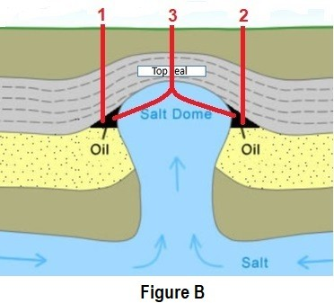

(CO2) [Comprehension]

* 1. Source rocks are classified by the types of Kerogen that they contain, which in turn governs the type of hydrocarbons that will be generated.
     1. Name the type of source rock that is responsible for the generation of waxy crude oils.
     2. Explain the conditions that need to be fulfilled for the formation of various source rocks that generate (i) waxy crude oils, (ii) both oil and gas, and (iii) mostly gas with light oil.

(CO2) [Comprehension]

* 1. Assume that you have joined an Oil and Gas exploration company as an Assistant Driller recently and you got your posting in a drilling rig. You have been informed that a reservoir is expected at about 4500 m depth. Suddenly, the Wellsite Geologist asked you to stop the drilling around 300 m before the target depth after examining the drill cuttings and also convinced the management that the oil and gas can’t be found below the present depth. As per the drill cuttings, the cuttings of shale, sandstone, mudstone, dolerite, gneiss, and graphite from the same well are received. (a) Identify the rock cuttings that helped the Wellsite Geologist to stop drilling. (b) Explain the reason(s) cited for confirming that oil and gas can’t exist in deeper depth.

(CO2) [Comprehension]

* 1. Figure D below depicts a cycle that explains the opening and closing of an ocean basin. (a) Write the name of that cycle. (b) Illustrate the Figure D.

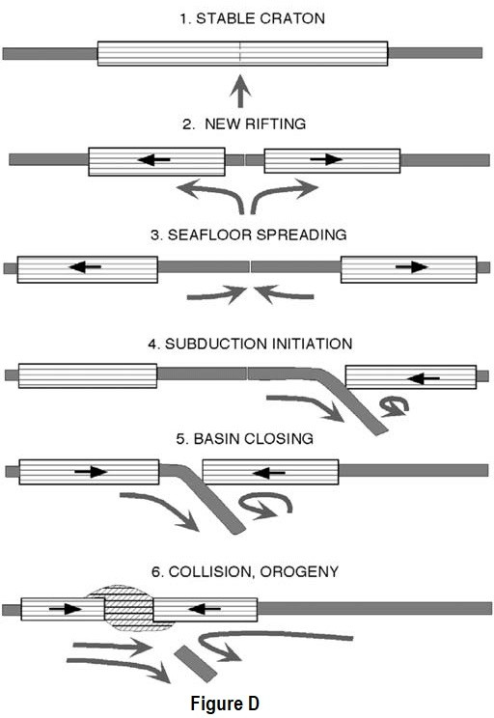

(CO3) [Comprehension]

* 1. (a) Define a sedimentary basin and explain the primary mechanisms of basin formation.

(b) Describe the relationship between plate tectonics and sedimentary basins.

(CO3) [Comprehension]

# PART C

**ANSWER ANY TWO QUESTIONS 2QX20M=40**

* 1. (a) Describe the major types of depositional environments, focusing on continental, marginal-marine, siliciclastic marine, and carbonate environments.

(b) Discuss the formation, processes, and characteristics of evaporite environments, and provide examples of where these environments can be found.

(CO1) [Application]

* 1. The hydrocarbon potential of organic carbon depends on the thermal history of the rocks containing the kerogen. Both temperature and time are important to determine the maturity of Organic Matter (OM). Name all the methods used for measuring the maturity of OM and explain them.

(CO2) [Application]

* 1. Figure I (a and b) is displaying two important concepts in geology that describe how the shoreline of a body of water moves over time. Distinguish those two important concepts from Figure I.

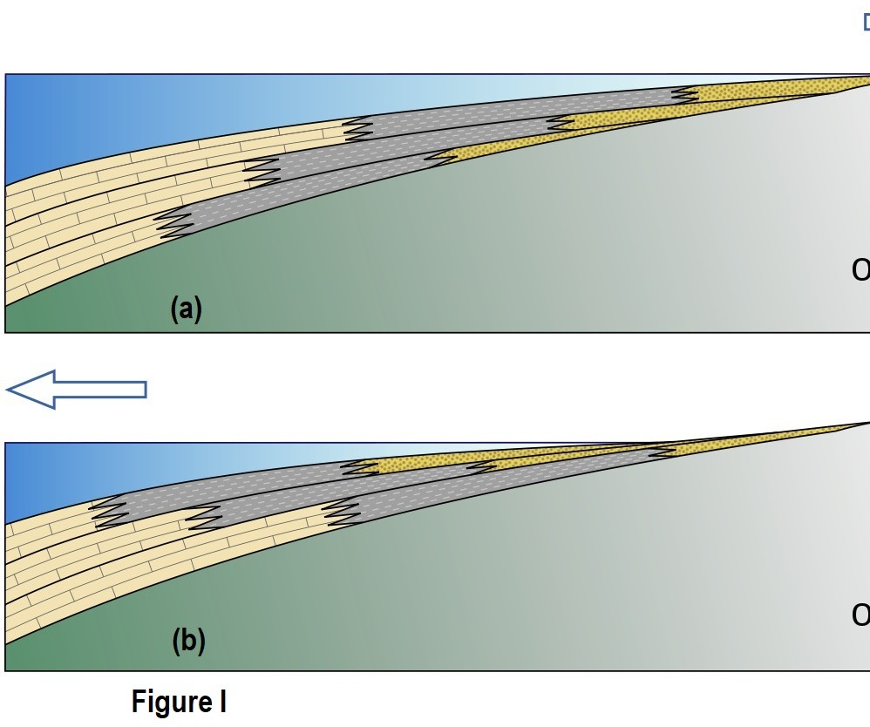

(CO3) [Application]