|  |  |  |  |  |  |  |  |  |  |  |  |
| --- | --- | --- | --- | --- | --- | --- | --- | --- | --- | --- | --- |
| Roll No |  |  |  |  |  |  |  |  |  |  |  |



PRESIDENCY UNIVERSITY BENGALURU

**SET-B**

SCHOOL OF ENGINEERING

**END TERM EXAMINATION –MAY/ JUNE 2024**

**Semester :** Semester IV - 2022

**Course Code :** PET2002

**Course Name :** Fundamentals of Geophysical Logging Techniques

**Program :** B. Tech. Petroleum Engineering

**Date :** June 12, 2024

**Time :**9:30AM-12:30 PM

# Max Marks : 100

**Weightage :** 50%

# Instructions:

1. *Read all questions carefully and answer accordingly.*
2. *Question paper consists of 3 parts.*
3. *Scientific and non-programmable calculator are permitted.*
4. *Do not write any information on the question paper other than Roll Number.*

**PART A**

**ANSWER ANY FIVE QUESTIONS 5QX2M=10**

1. Tell at least two objectives of well logging.
2. Describe Formation Factor.
3. Recall the limitations of induction logging.
4. Explain the principle of the induction log.
5. Mention one key application of the NMR log in reservoir evaluation.
6. Mention two key applications of production logging.
7. Identify the principle behind using cross-plots in petrophysical analysis.

(CO1) [Knowledge] (CO2) [Knowledge] (CO3) [Knowledge] (CO3) [Knowledge] (CO4) [Knowledge] (CO4) [Knowledge] (CO5) [Knowledge]

**PART B**

**ANSWER ANY FIVE QUESTIONS 5QX10M=50**

1. Compare and contrast Logging While Drilling (LWD) and Wireline Open Hole Logging in terms of their methodologies, advantages, and limitations.

(CO1) [Comprehension]

1. Investigate the effects of borehole invasion on resistivity measurements and propose correction techniques to enhance data accuracy.

(CO2) [Comprehension]

1. Analyze the relationship between porosity and resistivity, and discuss how the formation factor is used to quantify this relationship.

(CO2) [Comprehension]

1. Formulate a well logging program for a deepwater drilling project, considering the unique challenges and required tools. Explain your choices.

(CO3) [Comprehension]

1. Discuss the limitations of sonic logs in highly fractured or unconsolidated formations and suggest how to overcome these limitations.

(CO3) [Comprehension]

1. Evaluate the limitations of CBL/VDL logs in highly deviated wells and propose alternative methods for cement evaluation.

(CO4) [Comprehension]

1. Evaluate the limitations of Sonic-Neutron cross-plots in highly shaly formations and propose methods

to overcome these challenges.

(CO5) [Comprehension]

**PART C**

**ANSWER ANY TWO QUESTIONS 2QX20M=40**

1. (a) Calculate the formation temperature at a depth of 3000 meters, given a surface temperature of 20°C and a geothermal gradient of 25°C/km. To calculate the formation temperature, use the formula:

𝑇𝑓 = 𝑇𝑠 + (𝐺g×𝐷), where 𝑇𝑓 = Formation Temperature, 𝑇𝑠 = Surface Temperature, 𝐺g = Geothermal Gradient, 𝐷 = Depth.

Analyze how variations in the geothermal gradient can impact the estimation accuracy. [5+5 marks]

(b) Analyze the relationship between formation resistivity factor (F) and porosity (φ) using Archie's equation, given 𝐹 = 1/𝜑𝑚. Calculate the formation resistivity factor for a formation with a porosity of

0.15 and a cementation exponent (m) of 2.

Evaluate the importance of the cementation exponent in this relationship. [5+5 marks]

NOTE: You may need to correct the given equation.

(CO2) [Application]

1. (a) Calculate Porosity (ɸD) from Formation Density Log (ρb) when,
   1. ρb = 2.63 g/cc (Sandstone), ρma = 2.75 g/cc (Calcite), and ρf = 1.12 g/cc (Salt Mud)
   2. ρb = 2.61 g/cm3 (Sandstone), ρma = 2.75 g/cm3 (Calcite), and ρf = 1.2 g/cm3 (Salt Mud)
   3. ρb = 2.31 g/cc (Limestone), ρma = 2.75 g/cc (Calcite)
2. Estimate porosity by plotting the given data on Chart 3. Chart 3:

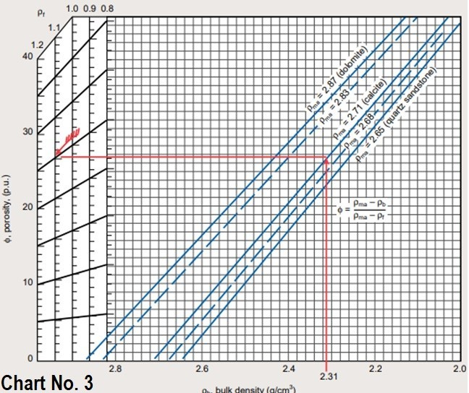

1. Compare the output of (a) and (b). [12 + 6 + 2 marks]

(CO3) [Application]

1. The geophysical log data for PU Well 4 is shared below. Identify the correct charts and determine cross-plot porosity as well as lithology for the freshwater-invaded zone using the following cross-plot techniques.
2. Neutron Porosity – Bulk Density
3. Sonic Transit Time – Bulk Density

Compare the results of all data points (i.e. Sl. No. 1 through 8) for both cross-plots as two different cross-plot techniques are used for determining the porosity and lithology of the same formation.

**PU Well 4: Geophysical Log Data**

**Sl. Depth Cal**

**GR RHOB NPHI RES_DEEP RES_SHAL RES_MICR DT**

**DTS**

**No. (ft)**

**(inch) (API) (g/cc) (frac) (Ohm_m) (Ohm_m) (Ohm_m) (µs/ft)**

|  |  |  |  |  |  |  |  |
| --- | --- | --- | --- | --- | --- | --- | --- |
| 1 | 616.46 9.21 | 97.17 2.65 | 0.12 | 19.74 | 21.77 | 22.50 | 70.16 158.65 |
| 2 | 623.16 8.79 | 48.66 2.54 | 0.05 | 13.04 | 15.58 | 23.72 | 63.15 115.85 |
| 3 | 626.97 8.56 | 33.51 2.48 | 0.07 | 16.58 | 16.57 | 7.79 | 64.39 110.51 |
| 4 | 637.95 8.68 | 82.60 2.58 | 0.06 | 19.58 | 23.02 | 25.06 | 68.28 148.22 |
| 5 | 643.59 8.63 | 26.04 2.39 | 0.12 | 2.41 | 2.36 | 1.85 | 68.16 113.36 |
| 6 | 647.85 8.60 | 22.92 2.40 | 0.12 | 0.99 | 0.81 | 1.18 | 68.92 121.84 |
| 7 | 653.80 8.60 | 45.37 2.50 | 0.09 | 4.35 | 4.39 | 2.60 | 70.68 134.80 |
| 8 | 668.27 8.90 | 60.00 2.68 | 0.17 | 8.83 | 8.28 | 19.87 | 68.28 137.26 |

Fill out the following Tables with your findings. Table 1:

1. **Neutron Porosity – Bulk Density Cross-plot**

**Sl.**

**No.**

1

2

3

4

5

6

7

8

**Chart No. Cross-plot**

**Porosity**

**Lithology**

Table 2:

1. **Sonic Transit Time – Bulk Density Cross-plot**

**Sl.**

**No.**

1

2

3

4

5

6

7

8

**Chart No. Cross-plot**

**Porosity**

**Lithology**

**Charts for cross –plots**

**Chart 1** :

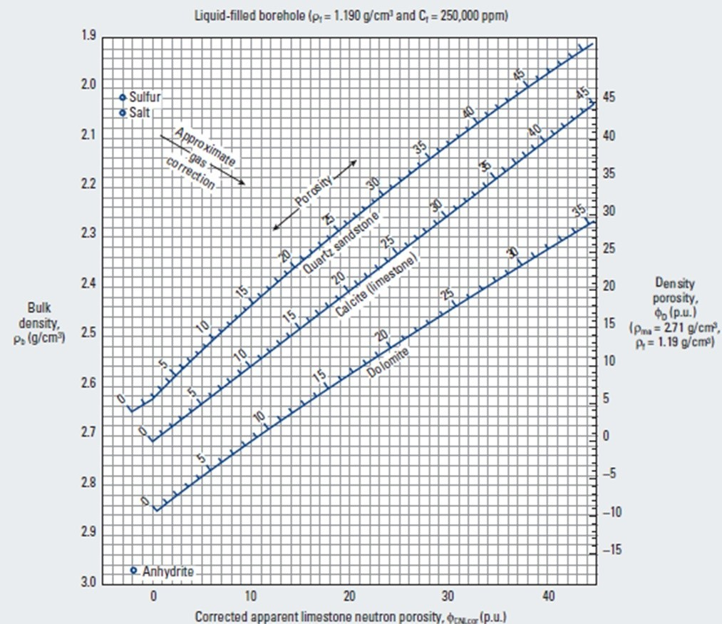

**Chart 2:**

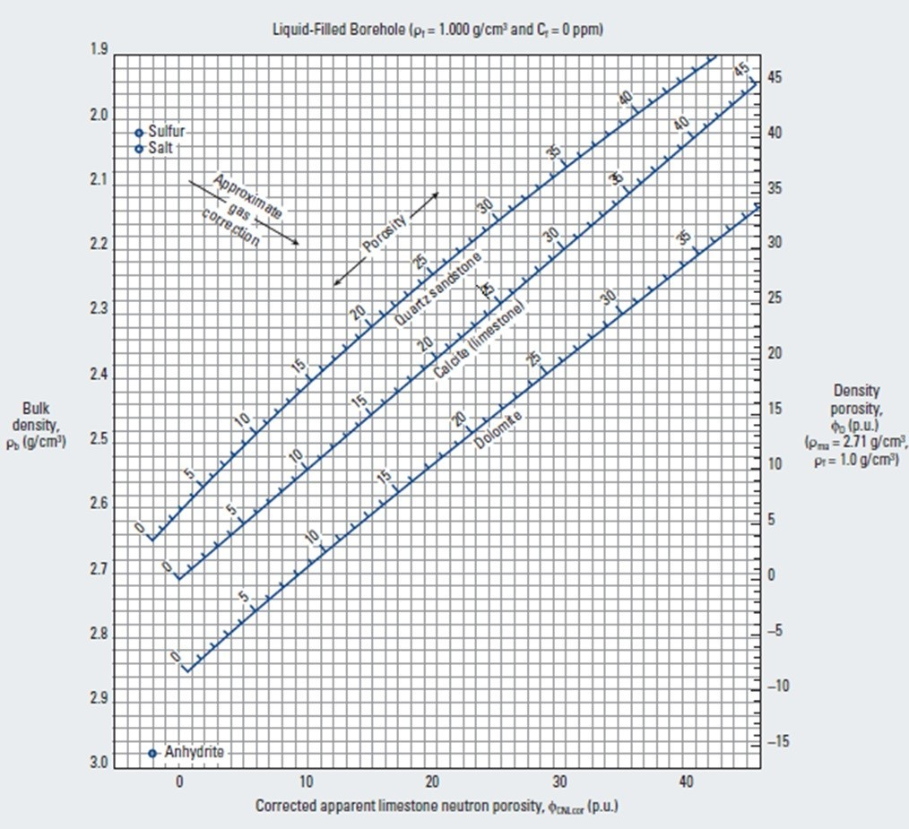

**Chart 3:**

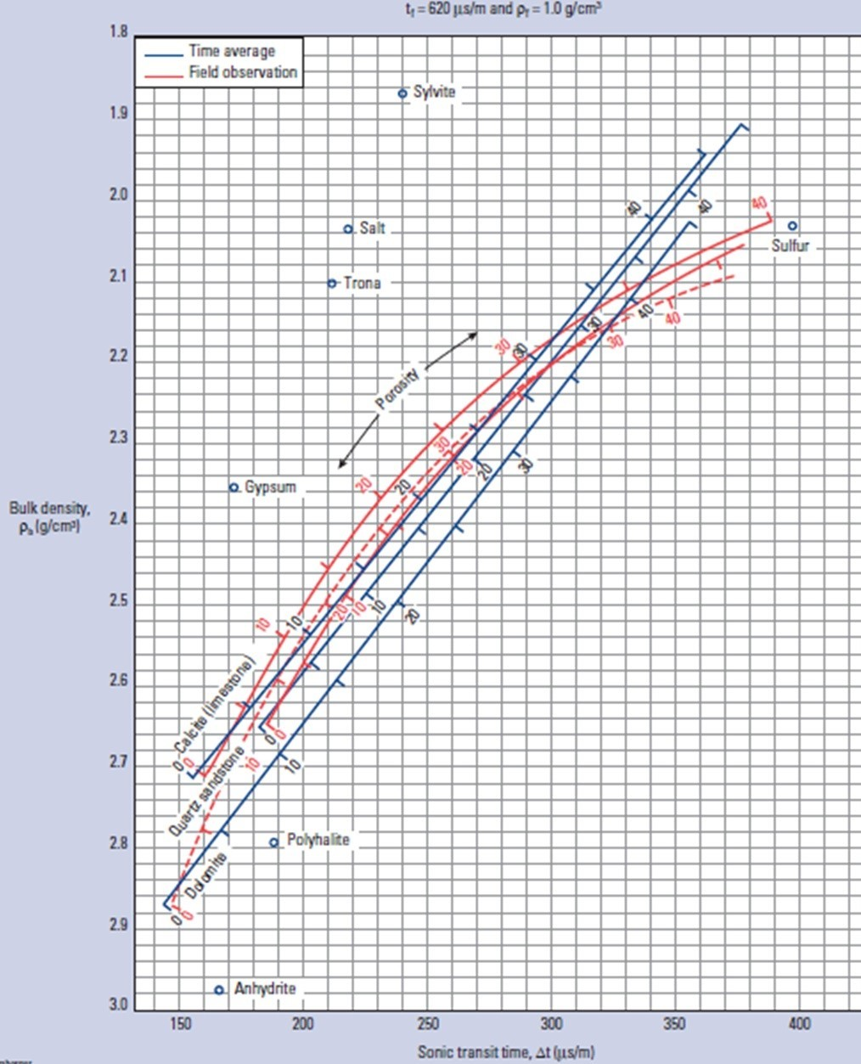

**Chart 4:**

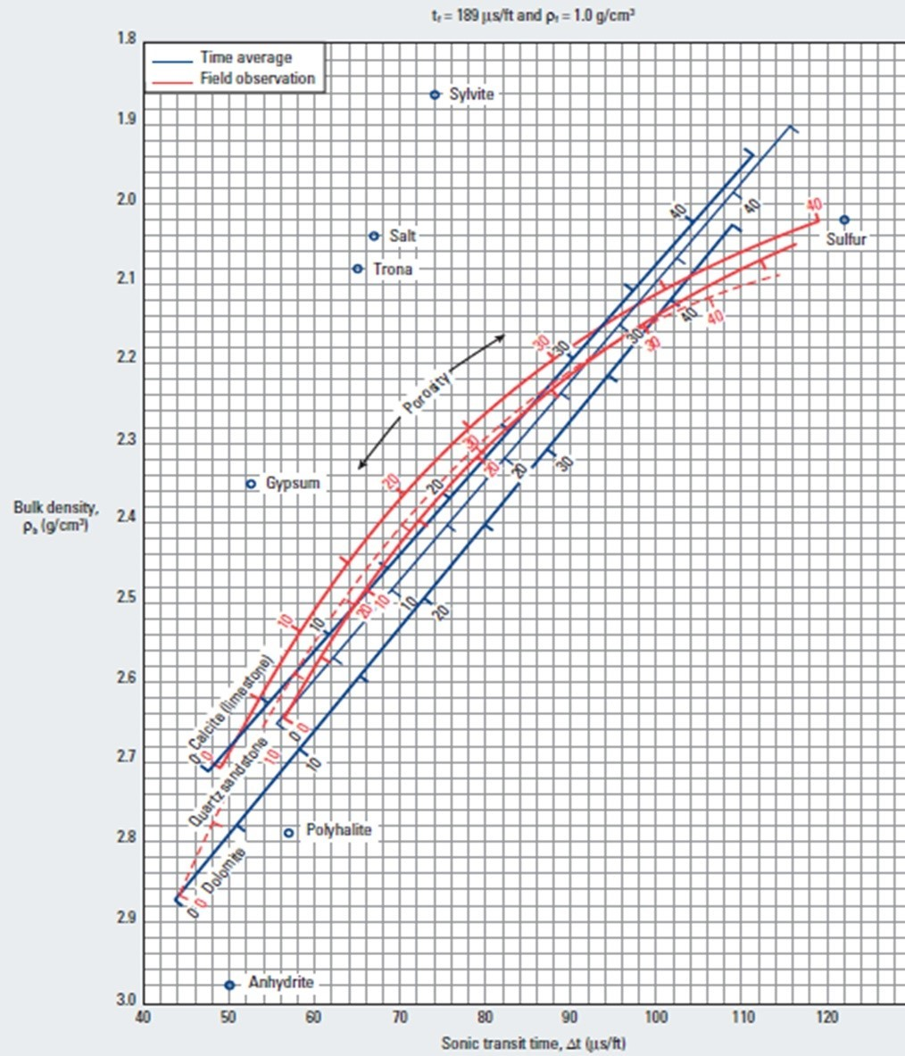

(CO5) [Application]