|  |  |  |  |  |  |  |  |  |  |  |  |
| --- | --- | --- | --- | --- | --- | --- | --- | --- | --- | --- | --- |
| Roll No |  |  |  |  |  |  |  |  |  |  |  |

PRESIDENCY UNIVERSITY BENGALURU

**SET B**

SCHOOL OF ENGINEERING

**END TERM EXAMINATION – MAY / JUNE 2024**

**Semester :** Semester IV - 2022

**Course Code :** PET2004

**Course Name :** Fundamentals of Petroleum Reservoir Engineering

**Program :** B.Tech.

**Date :** June 13, 2024

**Time :** 09.30am - 12.30pm

# Max Marks : 100

**Weightage :** 50%

**Instructions:**

1. *Read all questions carefully and answer accordingly.*
2. *Question paper consists of 3 parts.*
3. *Scientific and non-programmable calculator are permitted.*
4. *Do not write any information on the question paper other than Roll Number.*

**PART A**

**ANSWER ANY FIVE QUESTIONS 5QX2M=10M**

* 1. Capillary pressure (𝑃c) vs water saturation (𝑆w) curves for different sandstone reservoirs (I, II, III and IV) are given in the following figure. Which reservoir has the most uniform pore size distribution and why?

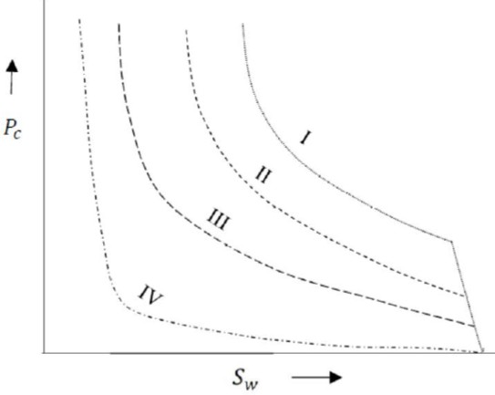

* 1. Define surface tension and Interfacial tension.

(CO1) [Knowledge]

(CO2) [Knowledge]

* 1. Write Leverett J-function.
  2. Identify the drive mechanism:

(CO2) [Knowledge]

* + 1. The density differences between oil and gas and water result in their natural segregation in the reservoir. This process can be used as a drive mechanism, but is relatively weak, and in practice is only used in combination with other drive mechanisms.
    2. In practice a reservoir usually incorporates at least two main drive mechanisms. So a reservoir with two drive mechanism is called as…
    3. The drive energy is provided by an aquifer that interfaces with the oil in the reservoir at the oil-water contact (OWC).
    4. This drive mechanism requires the reservoir rock to be completely surrounded by impermeable barriers. As production occurs the reservoir pressure drops, and the exsolution and expansion of the dissolved gases in the oil and water provide most of the reservoirs drive energy.
  1. Express compressibility equation in terms of density.
  2. Define the drive mechanism of a reservoir.

(CO3) [Knowledge] (CO3) [Knowledge]

(CO4) [Knowledge]

* 1. “The isothermal compressibility coefficient is essentially the controlling factor in identifying the type of the reservoir fluid. In general, reservoir fluids are classified into three groups”-Mention those.

(CO4) [Knowledge]

**PART B**

**ANSWER ANY FIVE QUESTIONS 5QX10M=50M**

* 1. ''Wetting phase always occupy the smaller pores and non wetting phase always occupy larger pores''. Justify the statement using relative permeability concept. Explain all the four points in relative permeability graph given below.

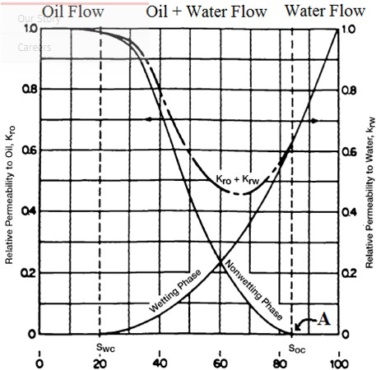

(CO1) [Comprehension]

* 1. Hydrocarbon reservoir can be classified based on initial reservoir pressure and composition of reservoir fluid. Classify the hydrocarbon reservoir based on above mentioned parameter. Explain retrograde condensate phenomena with diagram.

(CO2) [Comprehension]

* 1. The generalize MBE is given below,

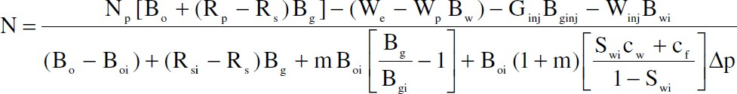

Modify the equation for the following cases

* + 1. For a solution gas drive reservoirIt is assumed that there is no initial gas cap The aquifer is relatively small in volume and the water influx is negligible. Under saturated reservoir

No Water and Gas Injection

* + 1. For a solution gas drive reservoirActive aquifer It is assumed that there is no initial gas cap Saturated reservoir

Implemented Water flooding

* + 1. Also write the recovery expression from the equation for no implementation of secondary recovery, no initial gas cap and no active aquifer.

(CO3) [Comprehension]

* 1. Given a fluid flowing linearly through a porous medium, based on the provided pressure-volume and

pressure-position conditions, derive the fundamental flow equation.



(CO3) [Comprehension]

* 1. Do as Directed (3+3+4)
     1. Differentiate between Primary, Secondary, and Tertiary drive mechanisms.
     2. Compare the characteristics of various primary drive mechanisms in a tabulated form. Comparison should be based on driving energy, recovery percentage and GOR.
     3. Illustrate with a diagram showing the placement of wells in a reservoir supported by a gas cap drive and provide a justification for the chosen positions.

(CO3) [Comprehension]

* 1. Elaborate on the working principles of the Solution drive mechanism and gravity drainage drive mechanism in primary oil recovery, including graphical representation of the pressure decline profile and ultimate recovery.

(CO4) [Comprehension]

* 1. Discuss the interplay between active water drive and primary gas cap drive in the combination drive mechanism, and analyze how the synergy of these mechanisms enhances oil recovery in a reservoir. What are the potential challenges and benefits of this combined approach in maximizing extraction efficiency and managing reservoir pressure?

(CO4) [Comprehension]

**PART C**

**ANSWER ANY TWO QUESTIONS 2QX20M=40M**

* 1. An oil well is producing at a constant flow rate of 300 STB/day under unsteady-state flow conditions. The reservoir has the following rock and fluid properties:

Oil formation volume factor Βo = 1.25 bbl/STB, Viscosity μo = 1.5 cp, Total compressibility ct = 12 × 10−6 psi−1, Permeability ko = 60 md, Height of pay zone h = 15 ft, pi = 4000 psi, Porosityφ = 15%, Wellbore radius rw = 0.25 ft

Calculate pressure at radii of 0.25, 5, 50, 100, 500, 1000, and 2500 feet, for 1 hour. Plot the results as: Pressure versus radius

(CO2) [Application]

* 1. A combination-drive reservoir contains 10 MMSTB of oil initially in place. The ratio of the original gas- cap volume to the original oil volume, i.e., m, is estimated as 0.25. The initial reservoir pressure is 3000 psia at 150°F. The reservoir produced 1 MMSTB of oil, 1100 MMscf of 0.8 specific gravity gas, and 50,000 STB of water by the time the reservoir pressure dropped to 2800 psi. The following PVT is available:

Estimate the following:

* + 1. Cumulative water influx
    2. Net water influx
    3. Primary driving indexes at 2800 psi

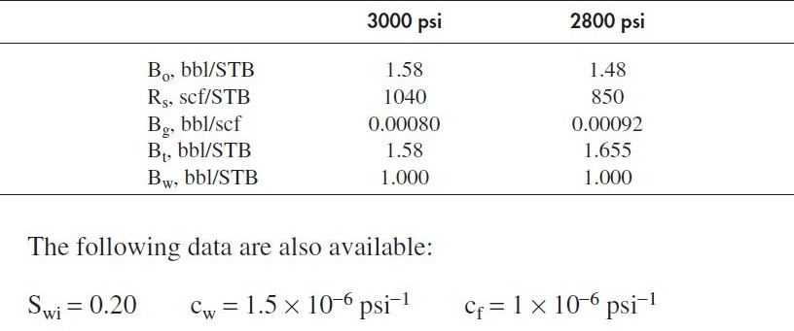

(CO3) [Application]

* 1. An incompressible fluid (density = 40 lb/ft3) flows at a steady state through a linear porous media with

the following properties: 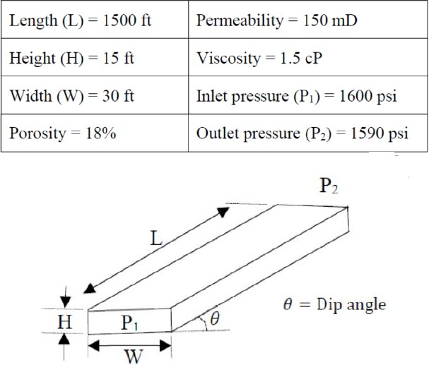

The absolute value of the difference between the actual fluid velocity (ft/day) at θ = 0ᵒ and θ = 10ᵒ is

(rounded off to three decimal places).

(CO4) [Application]