|  |  |  |  |  |  |  |  |  |  |  |  |
| --- | --- | --- | --- | --- | --- | --- | --- | --- | --- | --- | --- |
| Roll No |  |  |  |  |  |  |  |  |  |  |  |



PRESIDENCY UNIVERSITY BENGALURU

**SET-B**

SCHOOL OF ENGINEERING

**END TERM EXAMINATION – MAY/JUNE 2024**

**Semester:** Semester IV - 2022

**Course Code:** PET2012

**Course Name:** Reservoir Fluid Mechanics

**Program:** B. Tech.

**Date :** June 19, 2024

**Time :** 9:30 AM - 12:30 PM

# Max Marks : 100

**Weightage :** 50%

# Instructions:

1. *Read all questions carefully and answer accordingly.*
2. *Question paper consists of 3 parts.*
3. *Scientific and non-programmable calculator are permitted.*
4. *Do not write any information on the question paper other than Roll Number.*

**PART A**

**ANSWER ANY FIVE QUESTIONS 5QX2M=10**

1. State Bernoulli’s Theorem.
2. Define Co-efficient of Discharge (Cd).
3. Define shear velocity and give its mathematical expression.

(CO3) [Knowledge] (CO3) [Knowledge] (CO4) [Knowledge]

1. Draw and state the profile for velocity distribution and shear stress for a laminar flow in a circular pipe.

(CO4) [Knowledge]

1. Define Mach number. Also, state its significance.
2. Describe specific gravity. Write down its unit and dimensional formula.
3. Distinguish between laminar and turbulent flow.

(CO4) [Knowledge] (CO1) [Knowledge] (CO2) [Knowledge]

**PART B**

**ANSWER ANY FIVE QUESTIONS 5QX10M=50**

1. Two venturi meters of different area ratios are connected at different locations of the same pipeline. Similar manometers are used across 2 venturi meters to measure discharge the first venturi meter with an area ratio of 2 registers a pressure difference of "x" while the second Venturi meter registers it as "5x". Estimate the area ratio of the second venturi meter.

(CO3) [Comprehension]

1. A pitot tube is used to measure the velocity of water using a differential guage which contains manometric fluid of specific gravity 1.4. If the velocity of water in the pipeline is 1.2 meter per second, estimate the manometric fluid deflection.

(CO3) [Comprehension]

1. If a pipe (siphon) draws water from a reservoir and discharges it out atmospheric pressure as shown in the figure. Assuming the ideal fluid and reservoir is very large, predict the velocity at joint P in the pipe.

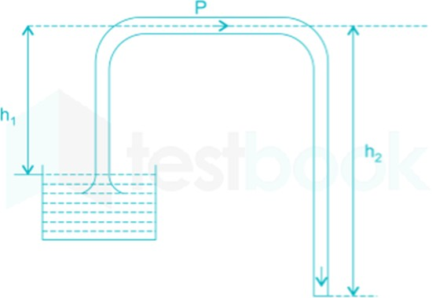

(CO3) [Comprehension]

1. The orifice meter is a significant tool in fluid measurement due to its cost-effectiveness, simplicity, versatility, and reliability. Its ability to measure a wide range of fluids accurately and its compliance with industry standards make it an essential device across various industries. Discuss in detail orifice meter with a neat diagram.

(CO3) [Comprehension]

1. An orifice meter with the coefficient of discharge, Cd = 0.61, is substituted by a venturi meter with, Cd

= 0.98, in a pipeline carrying crude oil. The venturi meter has the same throat diameter as that of the orifice meter. Interpret the ratio of pressure drops for the Venturi meter to that of the orifice meter if the flow rate is the same for both cases.

(CO3) [Comprehension]

1. A syringe with a frictionless plunger contains water and has at its end a 100 mm long needle of 1 mm diameter. The internal diameter of the syringe is 10 mm. The plunger is pushed in at 10 mm/s and water comes out as a jet. Assuming ideal flow, estimate the force F in Newton required on the plunger to push out the water. Given that the viscosity of the water is 0.001 N.s/m2.

(CO4) [Comprehension]

1. Crude oil flows through a 100 m long steel pipe of 150 mm diameter. The pressure at section 1 is
   1. MPa and section 2 is 0.95 MPa. The density and kinematic viscosity of the fluid is 918 kg/m3 per meter cube and 412.5 m2/s respectively. Estimate
      1. Velocity of the fluid
      2. Reynolds number
      3. Discharge of the fluid
      4. Friction factor of the pipe

(CO4) [Comprehension]

**PART C**

**ANSWER ANY TWO QUESTIONS 2QX20M=40**

1. An crude oil with a density of 900 kg/m³ and kinematic viscosity of 0.0002 m²/s flows upward through an inclined pipe as shown. Establish the direction of the fluid flow. Assuming steady laminar flow, compute
2. Head loss between two points
3. Velocity of the fluid
4. flow rate
5. Reynolds Number

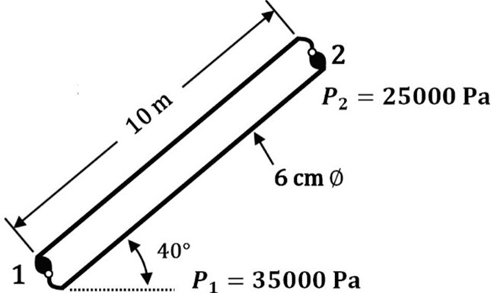

(CO4) [Application]

1. Carbon dioxide flows steadily through a varying cross-sectional area duct, such as a nozzle, at a mass flow rate of 3 kg/s. The CO₂ enters the duct at a pressure of 1400 kPa and a temperature of 200°C with a low velocity, and it expands in the nozzle to a pressure of 200 kPa. The duct is designed so that the flow can be approximated as isentropic. Determine the following at each location along the duct corresponding to a pressure drop of 200 kPa:
2. Density
3. Velocity
4. Flow area
5. Mach number

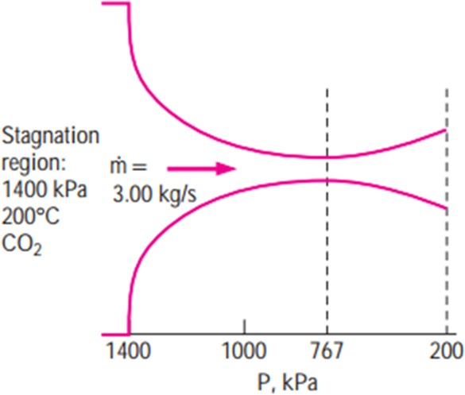Assume Cp = 0.846 KJ/Kg.K and γ = 1.289

(CO4) [Application]

1. A jet of water emerges from a nozzle (75 mm in diameter) connected to a pipe (225 mm in diameter) as shown in the figure. The velocity of the water at the point is 18 m/s. The friction in the pipe and nozzle is negligible. Calculate the velocity of the water at the nozzle point. Also, calculate the gauge pressure at point B in KPa.

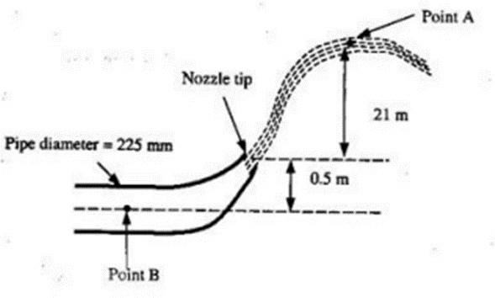

(CO3) [Application]