Roll No


PRESIDENCY UNIVERSITY
BENGALURU
SET-A
SCHOOL OF ENGINEERING
END TERM EXAMINATION – MAY/JUNE 2024

Semester : II - 2023 - 24 - BCA - 2023 | Date : JUNE 20-2024
Course Code : CSA2001 | Time : 9:30 AM -12:30 PM
Course Name : Data Structures and Algorithms | Max Marks :100
Program : BCA | Weightage : 50%
________________________________________________________________________________________________
Note: 1. Answer ALL 5 FULL Questions.
2. Each Full Question carries 20 Marks
3. Scientific and non-programmable calculator are permitted.
4. Do not write any information on the question paper other than Roll Number.

1.a. | Define data structure. List the different types of data structures. [Knowledge] | (CO1) | (04 Marks)
1.b. | Mr. Arjun is a nutritionist. He has started his profession newly. He wants a software that can take clients information such as age, height and weight and also display the information. Help Mr Arjun to create a new data type called cinfo and enable him to perform following operations. [Comprehension]  - Read clients info  Ii Display clients’ info. | (CO1) | (06 Marks)
1.c. | Convert K+L-M*N+(O^P) *W/U/V*T+Q into prefix. [Application] | (CO1) | (10 Marks)
OR
2.a. | Define a pointer. Explain how pointers can be declared and initialized. [Knowledge] | (CO1) | (04 Marks)
2.b. | Write a C program to swap 2 numbers and use the same to explain advantage of call by reference method over call by value method [Comprehension] | (CO1) | (06 Marks)
2.c. | Explain the various looping statements with suitable syntax and examples. [Application] | (CO1) | (10 Marks)
3.a. | List out any two real world applications of Linked list.  And write any two advantages of doubly link list over singly linked list. [Knowledge] | (CO2) | (04 Marks)
3.b. | Write a c program to print factorial of a number using recursion. [Comprehension] | (CO2) | (06 Marks)
3.c. | Write the C functions to perform the following in an doubly linked list.  a) inserting a new node as a first node.  b) deleting the last node of the list. [Application] | (CO2) | (10 Marks)
OR
4.a. | List the advantages and disadvantages of Recursion. [Knowledge] | (CO2) | (04 Marks)
4.b. | Write a C program for the tower of hanoi problem. [Comprehension] | (CO2) | (06 Marks)
4.c. | List all the operations that can be performed on an linked list. Write a c program to add the values of 4 nodes in a linked list using dynamic memory allocation. [Application] | (CO2) | (10 Marks)
5.a. | Define the following with respect to graph with an example [Knowledge]  a) digraph b) cycle | (CO3) | (04 Marks)
5.b. | Obtain the post order traversalling for the given tree. [Comprehension]  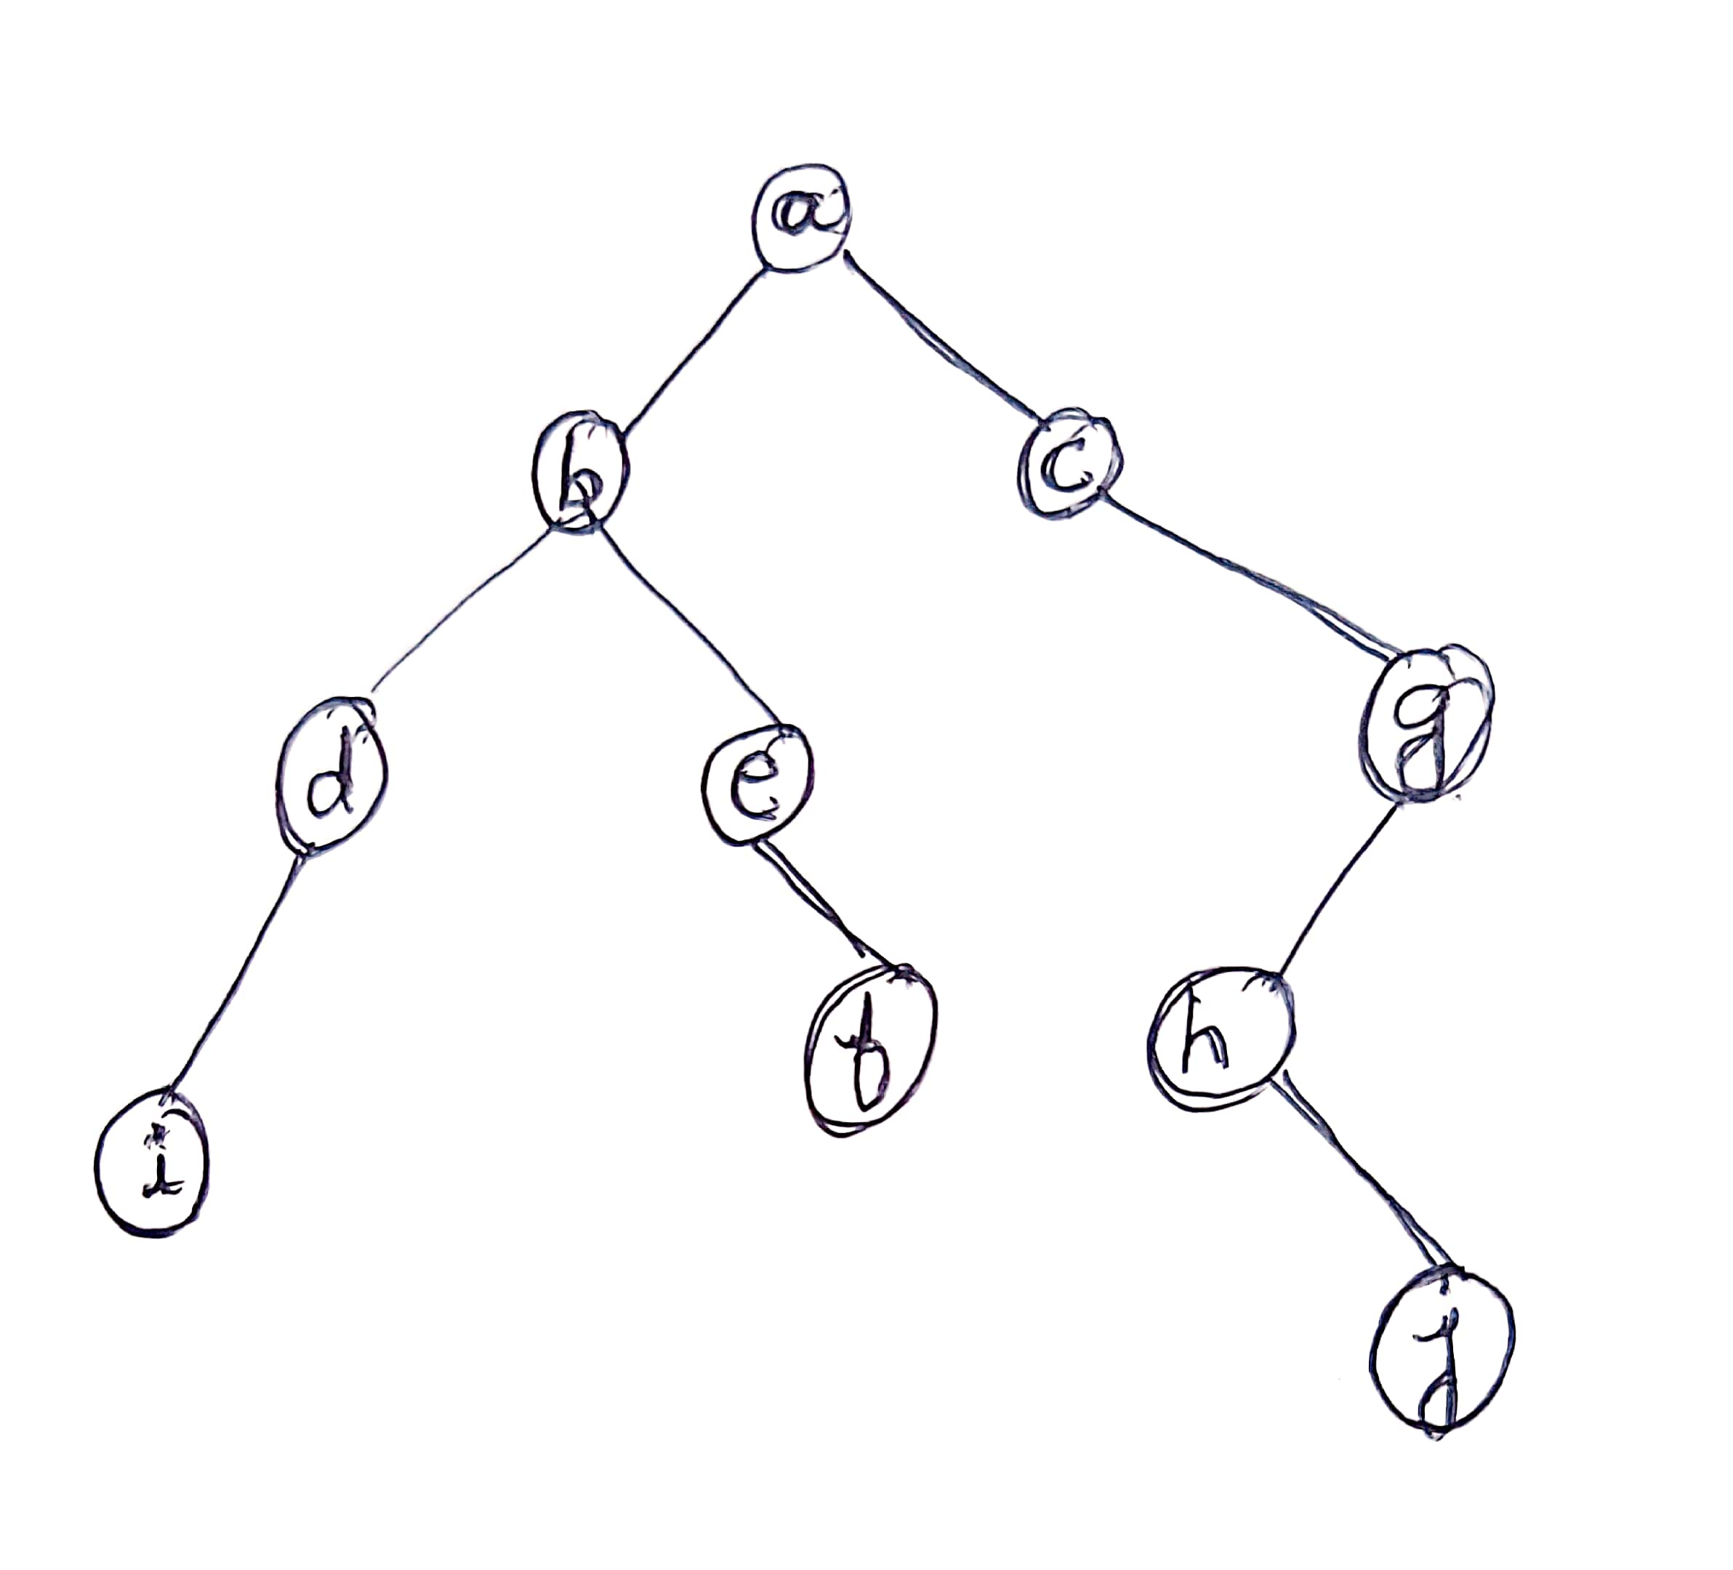 | (CO3) | (06 Marks)
5.c. | Define Graph. Explain the different types of graph representation with an appropriate example. [Application] | (CO3) | (10 Marks)
OR
6.a. | List any 2 differences between tree and graph. [Knowledge] | (CO3) | (04 Marks)
6.b. | Define the following terms with respect to tree [Comprehension]  a) child b) leaf c) height | (CO3) | (06 Marks)
6.c. | Explain call by value and call by reference with suitable examples. [Application] | (CO3) | (10 Marks)
7.a | List the different mathematical functions used in efficiency classes [Knowledge] | (CO4) | (04 Marks)
7.b. | Write the steps used to analyze the non-recursive algorithms [Comprehension] | (CO4) | (06 Marks)
7.c | Explain in detail about asymptotic notations (with graph and equations) used in analysis of algorithms [Application] | (CO4) | (10 Marks)
OR
8.a | Explain any two features of an algorithm. [Knowledge] | (CO4) | (04 Marks)
8.b. | Design an algorithm to search the given key element using binary search [Comprehension] | (CO4) | (06 Marks)
8c. | Ms Renita wants to search a particular student in the class to assign some task. Suggest her a plan by writing an linear search algorithm to search for the student. Also do its analysis. [Application] | (CO4) | (10 Marks)
9.a | Define the following with an suitable example. [Knowledge]  a) Complete Binary Tree b) Binary Search Tree | (CO3) | (04 Marks)
9.b | Explain pre-order tree traversalling method with a suitable example. [Comprehension] | (CO3) | (06 Marks)
9.c | Discuss the fundamental concepts of graph theory, including vertices, edges, and graphs' types (directed vs. undirected, weighted vs. unweighted). Explain the importance of graph theory in various fields and applications. Provide real-world examples to illustrate the relevance of graph theory concept [Application] | (CO3) | (10 Marks)
OR
10.a | Explain any one asymptotic notation in detail. [Knowledge] | (CO4) | (04 Marks)
10.b | Write an sequential search algorithm [Comprehension] | (CO4) | (06 Marks)
10.c | Mr Vishnu wants to find the top scorer in the class in his subject. Suggest him a plan by writing an algorithm to find the top scorer. Also do its analysis [Application] | (CO4) | (10 Marks)

