|  |  |  |  |  |  |  |  |  |  |  |  |
| --- | --- | --- | --- | --- | --- | --- | --- | --- | --- | --- | --- |
| Roll No |  |  |  |  |  |  |  |  |  |  |  |



PRESIDENCY UNIVERSITY BENGALURU

**SET-B**

SCHOOL OF ENGINEERING

**END TERM EXAMINATION –MAY/ JUNE 2024**

**Semester :** Semester IV - 2022

**Course Code :** CIV2013

**Course Name :** Analysis of Determinate Structures

**Program :** B.Tech.

**Date :** June 12, 2024

**Time :** 9:30 AM - 12:30 PM

**Max Marks :** 100

**Weightage :** 50%

**Instructions:**

1. *Read all questions carefully and answer accordingly.*
2. *Question paper consists of 3 parts.*
3. *Scientific and non-programmable calculator are permitted.*
4. *Do not write any information on the question paper other than Roll Number.*

# PART A

## Answer any 10 Questions 10*2=20

* 1. 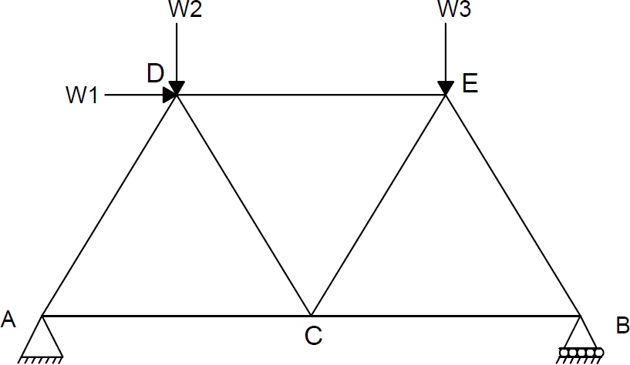Calculate the total degree of indeterminacy of a truss loaded as shown.

(CO1) [Knowledge]

* 1. Calculate the degree of indeterminacy of a simply supported beam loaded as shown in the figure below.

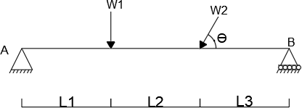

* 1. Calculate the degree of indeterminacy of a continuous beam loaded as shown.

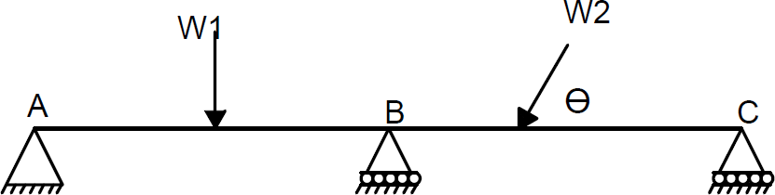

(CO1) [Knowledge]

(CO1) [Knowledge]

* 1. Calculate the total degree of indeterminacy of the fixed beam loaded as shown.

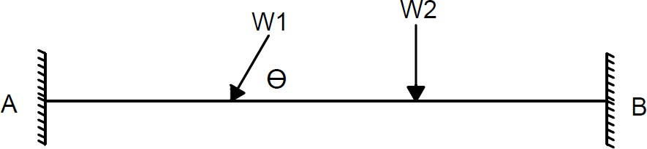

(CO1) [Knowledge]

* 1. Calculate the total degree of indeterminacy of a truss loaded as shown in figure below.

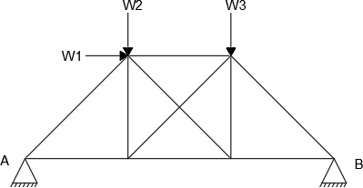

(CO1) [Knowledge]

* 1. Calculate degree of indeterminacy of a continuous beam loaded as shown in figure below.

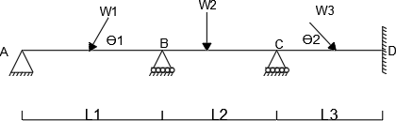

(CO1) [Knowledge]

* 1. Calculate the degree of indeterminacy of a continuous beam subjected to loads as shown in the figure below.

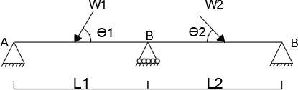

(CO1) [Knowledge]

* 1. Calculate the degree of indeterminacy of a continuous beam loaded as shown in figure.

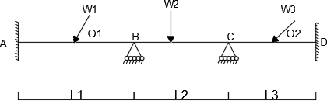

(CO1) [Knowledge]

* 1. Calculate the degree of indeterminacy of a simply supported beam loaded as shown.

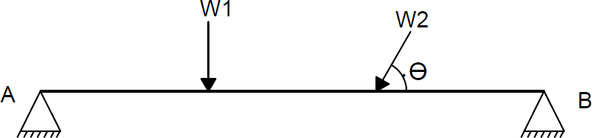

(CO1) [Knowledge]

* 1. 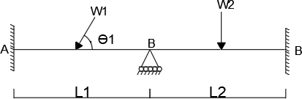Calculate the degree of indeterminacy of a continuous beam subjected to loads as shown in figure below.

(CO1) [Knowledge]

* 1. Calculate the total degree of indeterminacy of the propped cantilever beam loaded as shown in the figure below.

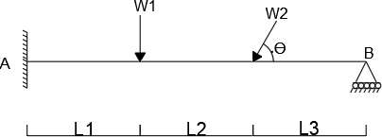

(CO1) [Knowledge]

* 1. Calculate the degree of indeterminacy of a propped cantilever beam loaded as shown.

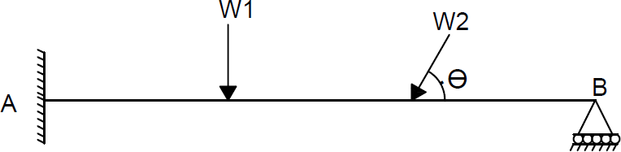

(CO1) [Knowledge]

* 1. Calculate the Kinematic degree of indeterminacy of a cantilever beam (axially rigid) shown in the figure below.

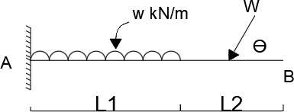

(CO1) [Knowledge]

* 1. Calculate the Kinematic degree of indeterminacy of a fixed beam (axially rigid) loaded as shown.

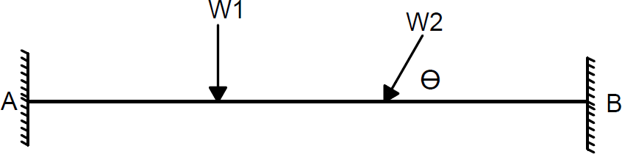

(CO1) [Knowledge]

# PART B

## Answer any 4 4*8=32

* 1. The suspension cable of span 60m, dip of the cable is 10 m, subjects to uniformly distributed load of magnitude 10kN/M throughout the length and it is supported at A & B. The supports are the same level. Calculate the maximum tensile force induces in the cable and also find the cross sectional area required for the cable, if maximum permissible tensile stress in the cable material is not to exceed 1200MPa.

(CO2) [Comprehension]

* 1. The three hinged symmetrical parabolic arch of span 50m, rise of 10m and subjected to UDL of magnitude 25 kN/m on left half of the arch. Calculate the support reactions and draw BMD.

(CO2) [Comprehension]

* 1. Calculate the maximum slope and deflection for cantilever beam loaded as shown in the figure by moment area method. Take EI = 10X kNm².

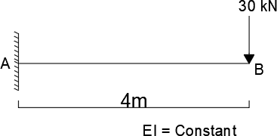

(CO3) [Comprehension]

* 1. Calculate maximum slope and deflection for simply supported beam loaded as shown in the figure by conjugate beam method. Take EI = 10X kNm².

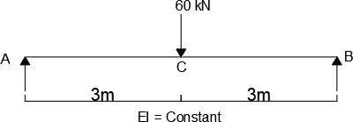

(CO3) [Comprehension]

* 1. Calculate the maximum slope and deflection for cantilever beam loaded as shown in figure by moment area method. Take EI = 10X kNm².

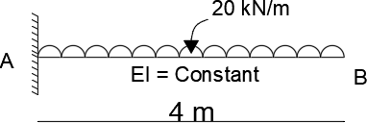

(CO3) [Comprehension]

* 1. Calculate the maximum slope and deflection for cantilever beam loaded as shown in the figure by conjugate beam method. Take EI = 8X kNm².

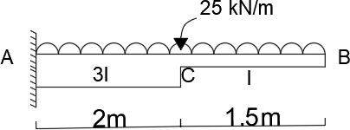

(CO3) [Comprehension]

# PART C

## Answer any 4 4*12=48

* 1. The suspension cable of span 50m, dip of the cable id 10 m, subjected to uniformly distributed load of magnitude 20kN/m throughout the length and it is supported at A & B. The supports are the same level. Calculate the maximum tensile force induced in the cable. Also calculate the vertical force and maximum bending on pier. Take back stay is ${60}^{0}$ with respect to vertical and height of the pier is 10m for the following supporting devices.

1. Friction less pulley
2. Saddle or Roller support

(CO2) [Application]

* 1. The three hinged symmetrical parabolic arch of span 50m and rise of 10m. The arch is subjected to point load of magnitude 300 kN at left quarter span. Calculate the support reactions and draw the BMD. Also find the normal thrust and radial shear at a distance 20m from the left support.

(CO2) [Application]

* 1. Analyze the fixed beam loaded as shown in figure by the consistent deformation method and draw the BMD and SFD. Take EI = Constant.

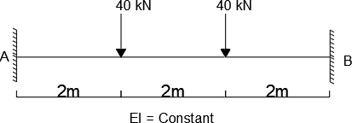

(CO4) [Application]

* 1. Analyze the fixed beam loaded as shown in figure by consistent deformation method and draw the BMD and SFD. Take EI = Constant.

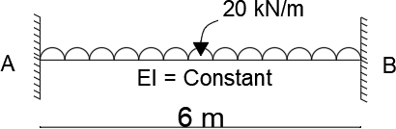

(CO4) [Application]

* 1. Analyze the propped cantilever beam loaded as shown in the figure by consistent deformation method and draw the BMD and SFD. Take EI as Constant.

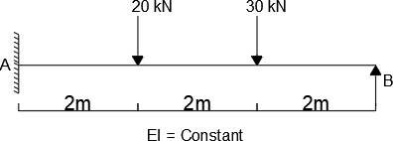

(CO4) [Application]

* 1. Analyze the propped cantilever beam subjected to loads as shown in the figure by consistent deformation method and draw the BMD and SFD. Take EI = Constant.

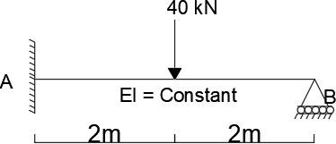

(CO4) [Application]