|  |  |  |  |  |  |  |  |  |  |  |  |  |
| --- | --- | --- | --- | --- | --- | --- | --- | --- | --- | --- | --- | --- |
| Roll No |  |  |  |  |  |  |  |  |  |  |  |  |



**Presidency University**

**Bengaluru**

**SCHOOL OF COMMERCE**

**SUMMER TERM - END-TERM EXAMINATIONS AUGUST,2024**

**Winter Semester**: 2023-2024

**Course Code**: BBA3008

**Course Name**: Advance Financial Accounting

**Program& Sem:** BBA

**Date**: 5 August 2024

**Time**:1:00 pm to 4:00 pm

**Max Marks**: 100

**Weightage**: 50%

**Instructions:**

1. *Read the all questions carefully and answer accordingly.*
2. *Question paper consists of three parts.*
3. *Scientific and Non Programable Calculators are Permitted.*
4. *Do not write any information on the question paper other than roll number.*

**Part - A**

**Answer any FIVE Questions. (5 Q x 2 M = 10 M)**

1. State the meaning of “Statutory Liquidity Ratio”. (CO1) [Knowledge ]

2. Discuss the concept of Rebate on bills discounted. (CO1) [Knowledge]

3. Discuss the Net Revenue Account (CO2) [Understand]

4. Give any four examples of Schedule 14 of a Banks final accounts (CO1) [Application]

5. State the meaning of Investment as per AS 13 (CO3) [Knowledge]

6. Explain the concept of general balance sheet. (CO2) [Understand]

7. Explain the concept of Cloud Computing accounting (CO4) [Knowledge]

**Part - B**

**Answer any FIVE Questions. (5 Q x 10 M = 50 M)**

8. From the following particulars, prepare Profit and Loss account of Sachin Bank Ltd for the year

ending 31st March 2024.

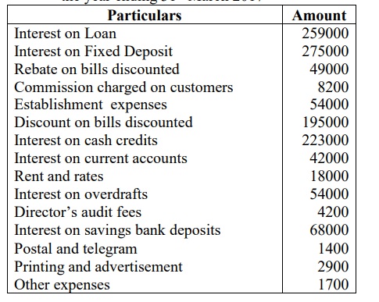

(CO1) [Application]

9. Bank is a financial institution which deals with others people’s money i.e., the money given by

Depositors. Explain the features of Banks. (CO 1) [Understand]

10. Differentiate between Single Account System and Double Account System (CO2) [Understand]

11.Discuss the advantages and disadvantages of Double Account System (CO2) [Understand]

12. Explain the impact of digital transformation on the accounting profession. How has

technology reshaped traditional accounting practices? (CO4) [Understand]

13. Elucidate the classification of investments and cost components of investments as per

AS-13 (CO3) [Application]

14. Define green accounting and explain its significance in today’s business environment. How

does green accounting contribute to sustainable development? (CO4) [Knowledge]

**Part - C**

**Answer any TWO Questions. (2 Q x 20 M = 40 M)**

15. Incorporate the following information in the balance sheet of National Bank Limited in Form “A” as

per the Banking regulation act 1949, with schedule as on 31st March 2010

.

|  |  |  |  |
| --- | --- | --- | --- |
| Capital | 5,00,000 | Contingent liabilities | 1,15,000 |
| borrowings | 1,00,000 | Advances | 3,26,000 |
| Deposits | 1,95,000 | Investments | 4,50,000 |
| Reserves and Surplus | 3,15,120 | Cash and balance with RBI | 1,93,000 |
| Balance with banks and money at call and short notice | 80,000 | Fixed assets | 48,000 |
| Other assets | 16,500 | other liabilities and provisions | 3,380 |

. (C.O.1) [Application]

16. The following balances are extracted from the books of M/s. Flashlight Electric Company Ltd.:

(i) Fixed assets : Expenditure up to 1.1.2016 :

(a) Land and Buildings ~ 10,00,000; (b) Machinery ~ 15,00,000.

(ii) Additions during the year ---- Machinery ~ 3,50,000

(iii) Depreciation Fund : (a) Machinery ~ 3,00,000; (b) Buildings ~ 1,00,000.

(iv) Authorized Capital ~ 50,00,000 divided into equity shares of ~ 100 each.

(v) Issued and fully paid-up 20,000 equity shares of ~ 100 each (including 2,500 equity shares issued

during the year).

(vi) 7.5 % Debentures ~ 10,00,000 secured by a charge on Fixed Assets.

(vii) Sundry Creditors ~ 2,50,000; Reserve Fund ~ 5,00,000; Reserve Fund Investments at cost ~

5,00,000; (Market value ~ 5,25,000).

(viii) Stock ~ 3,02,500; Sundry Debtors ~ 4,50,000; Cash at Bank ~ 2,00,000; Cash in hand ~ 50,000.

(ix) Profit and Loss Account (Cr.) ~ 2,02,500.

You are instructed to prepare :

(a) Capital Account

(b) General Balance Sheet as on the same date under the Double Account System (C.O.2) [Application]

17. Describe the process and accounting treatment for the disposal of investments. What is the key

steps involved in recording the sale of an investment? (CO3) [Knowledge]