|  |  |  |  |  |  |  |  |  |  |  |  |  |
| --- | --- | --- | --- | --- | --- | --- | --- | --- | --- | --- | --- | --- |
| Roll No |  |  |  |  |  |  |  |  |  |  |  |  |



**Presidency University**

**Bengaluru**

**SCHOOL OF COMMERCE**

**Summer Term End Term Examinations, August 2024**

**Winter Semester**: 2023 - 24

**Course Code**: BBB3026/BBB3005/MGI257

**Course Name**: Predictive Analytics

**Program & Sem**: SOC

**Date**: 12 / August / 2024

**Time**: 1:00 PM to 4:00 PM

**Max Marks**: 100

**Weightage**: 50%

**Instructions:**

1. *Read the all questions carefully and answer accordingly.*
2. *Question paper consists of three parts.*
3. *Scientific and Non Programable Calculators are Permitted.*
4. *Do not write any information on the question paper other than roll number.*

**Part A**

**Answer any FIVE Questions. (5 Q x 2 M = 10 M)**

1. List out the differences between simple and multiple regression. (C.O.4) [Remember]

2. Outline the difference between linear and logistic regression. (C.O.4) [Remember]

3. Define the coefficient of determination. (C.O.3) [Remember]

4. Recognize the importance of data preparation. (C.O.2) [Remember]

5. Outline the concept of outliers. (C.O.2) [Remember]

6. Define data imputation. (C.O.2) [Remember]

7. List out the characteristics of better-quality data. (C.O.2) [Remember]

**Part B**

**Answer any FIVE Questions. (5 Q x 10 M = 50 M)**

8. Describe the types of analytics with the help of examples. (C.O.1) [Understand]

9. Explain the various steps involved in cleaning data. (C.O.2) [Understand]

10. Summarize the importance of analytics in business. (C.O.1) [Understand]

11. Describe the applications of logistic regression (C.O.4) [Understand]

12. Explain the importance and applications of time series analysis (C.O.5) [Understand]

13. Summarize the practical applications of multiple linear regression in business (C.O.4) [Understand]

14. Explain the various assumptions of regression analysis. (C.O.3) [Understand]

**Part C**

**Answer any TWO Questions. (2 Q x 20 M = 40 M)**

15. Illustrate the benefits of predictive analytics in marketing, and human resources, with suitable examples for each. (C.O.1) [Apply]

16. Illustrate the practical implications of predictive analytics in finance and banking sectors with suitable examples  (C.O.1) [Apply]

17. Given below is the output of a regression analysis to predict the home market value. Interpret the result and write down the regression equation. Also, estimate the market value of a home whose square feet are given as 2500 sq ft.

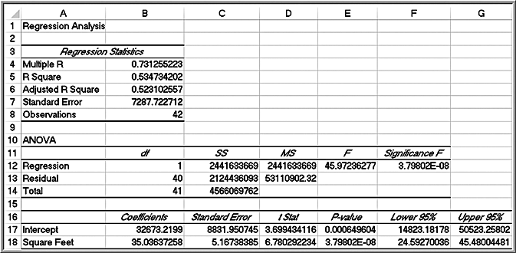

(C.O.4) [Apply]