|  |  |  |  |  |  |  |  |  |  |  |  |  |
| --- | --- | --- | --- | --- | --- | --- | --- | --- | --- | --- | --- | --- |
| Roll No |  |  |  |  |  |  |  |  |  |  |  |  |



**Presidency University**

**Bengaluru**

**SCHOOL OF ENGINEERING**

**SUMMER END TERM EXAMINATION AUGUST-2024**

**Date**: 05/August/2024

**Time**: 9.30 AM to 12.30 PM

**Max Marks**:100

**Weightage**: 50%

**Summer Term** : 2023-2024

**Course Code**: ECE2008**&061ECE3061**

**Course Name**: Signals and Systems

**Program & Sem**: ECE

**Instructions:**

1. *Read the all questions carefully and answer accordingly.*
2. *Do not write any matter on the question paper other than roll number.*
3. *Any tables/Chart/Graph or data books required, pl. mention here.*

**PART A**

**Answer any 5 Questions. Each question carries 6 marks. (5Qx 6M= 30M)**

1. The basic signal operations in digital signal processing (in time) are time shifting, time scaling and time reversal. Perform the time operations for the below given signal and plot $x(2t-1)$ .

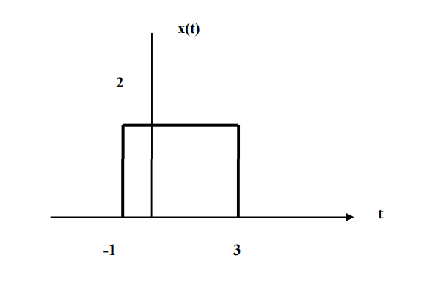

(CO1) [Knowledge]

1. The Laplace transform has a number of properties that make it useful for analysing linear dynamical systems. Explain time shifting property of Laplace transform

(CO1) [Knowledge]

1. The properties of z-transform can be used to find closed form of expression for the z-transform of a given sequence. State and prove the conjugation property of z-transform

(CO2) [Knowledge]

1. Evaluate the convolution sum y(n) of the following two discrete time signals

x(n) = (4, 1, 2, 3) and h(n) = (1, -2, -1, 2)

(CO2) [Knowledge]

1. What is the Z-transform, and how is it defined and also explain the properties of the Z-transform with an example.

(CO2) [Knowledge]

1. Evaluate the convolution sum y(n) of the following two discrete time signals

x(n) = (4, 1, 2, 3,4,5) and h(n) = (1, -2, -1, 2,-3,7)

(CO2) [Knowledge]

1. The Z transform has a number of properties that make it useful for analysing linear dynamical systems. Explain time shifting property of Z transform?

(CO2) [Knowledge]

**PART B**

**Answer any Four Questions. Each question carries 10 marks. (4Qx 10M= 40M)**

8. A continious-time signal is shown in Figure below. Sketch and label carefully each of the following signals:

(a) x[t- 4] b) x[t - 2] (c) x[t+2] (d) x(-t)



(CO2) [Comprehension]

9.The z-transform is a mathematical tool, which is used to convert the difference equations in time-domain into the algebraic equations in z-domain. Find the z-transform and also mention Region of Convergence [R.O.C] for the following signals.

(i) a^{n}u(n)  
(ii)-a^{n}u(-n-1). Justify the answers.

(CO2) [Comprehension]

10. What is Region of Convergence (ROC) of Z-Transform explain the Properties of ROC of Z-Transform, Explain ROC for three Different Types of Sequences mentioned below with an example

1. Left-Sided Sequence: ROC is ∣z∣>r.
2. Right-Sided Sequence: ROC is ∣z∣<r.
3. Two-Sided Sequence: ROC is r1<∣z∣<r2​.

(CO1) [Comprehension]

11. A finite sequence x (n) is defined as below find out the Z transform

1. X(n)=(5,2,-2,1,1,-3)

https://upload.wikimedia.org/wikipedia/commons/thumb/9/9e/U%2B2191.svg/12px-U%2B2191.svg.png

1. X(n)=(4,0,1,2,3,-4)

https://upload.wikimedia.org/wikipedia/commons/thumb/9/9e/U%2B2191.svg/12px-U%2B2191.svg.png

(CO1) [Comprehension]

12. A finite sequence x (n) is defined as below find out the Z transform

1. X(n)=(-3,-2,-1,0,1,-3)

https://upload.wikimedia.org/wikipedia/commons/thumb/9/9e/U%2B2191.svg/12px-U%2B2191.svg.png

1. X(n)=(1,0,-1,-2,3,-4)

(CO1) [Comprehension]



**PART C**

**Answer any two Questions. Each question carries 15 marks. (2Qx 15M= 30M)**

13. A discrete-time signal is shown in Figure below. Sketch and label carefully each of the following signals:

(a) x[n- 4] (b) x[n - 2] (c) x[n + 1] (d) x[-n]

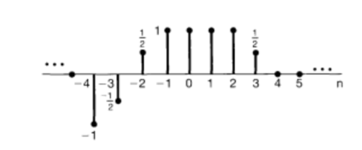

(CO1) [Application]

14. Given the discrete-time signals below, where u[n] is the unit step function, find the Z-transform X(z) and specify the Region of Convergence (ROC).

1. x[n]= 3^n u[n]+ 2^n u[n];
2. x[n]= 2^n u[n]+ 3 (1/2)^n u[n];
3. x[n]= 3 (-1/2)^n u[n]- 2[3^n u[-n-1];

(CO2) [Application]

15. Find the inverse Z-transform for the below expressions using the partial fraction method.

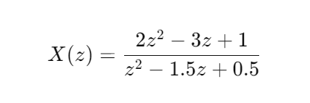a.

b.

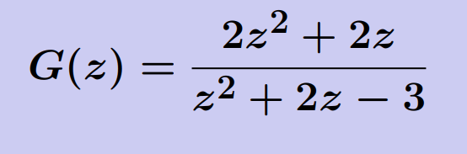

(CO2) [Application]