|  |  |  |  |  |  |  |  |  |  |  |  |
| --- | --- | --- | --- | --- | --- | --- | --- | --- | --- | --- | --- |
| Roll No |  |  |  |  |  |  |  |  |  |  |  |

PRESIDENCY UNIVERSITY BENGALURU

SCHOOL OF ENGINEERING

SUMMER TERM - END TERM EXAMINATION - AUGUST 2024

|  |  |
| --- | --- |
| **Semester : VII** | **Date : 05/08/2024** |
| **Course Code : CIV3001** | **Time : 1.00 pm to 4.00 pm** |
| **Course Name : Estimation, Costing and Valuation** | **Max Marks :100** |
| **Program : B. Tech** | **Weightage :50%** |

**Instructions:**

1. *Read all questions carefully and answer accordingly.*
2. *Scientific and non-programmable calculators are permitted.*

**Part A [Memory Recall Questions]**

**Answer any 5 Questions. Each Question carries 5 marks. (5Qx5M=25M)**

1. Explain the various methods of preparing preliminary estimates for (i) buildings, (ii) roads and Highways (iii) irrigation canals. [5M] (C.O.1) [Knowledge]

2. State the unit of measurement for the following items of work

i) Stone masonry work

ii) Marble flooring

iii) Partition wall

iv) Precast Concrete work

v) Painting on walls [5M] (C.O.1) [Knowledge]

3. Define contracts. Elaborate the types of contracts [5M] (C.O.2) [Knowledge]

4. What is Valuation? Explain the various purposes of Valuation. [5M] (C.O.3) [Knowledge]

5. Write a short note on gross income, net income, and outgoings [5M] (C.O.3) [Knowledge]

6. Define depreciation. Explain the methods of calculating depreciation. [5M] (C.O.3) [Knowledge]

7. Explain the various methods of measuring the quantity of earthwork for a road estimation.

[5M] (C.O.2) [Knowledge]

**Part B [Thought Provoking Questions]**

**Answer any 3 Questions. Each Question carries 10 marks. (3Qx10M=30M)**

7. Generally, the valuation of a building depends on the type of building, age, location, and structural design. A civil engineer needs to evaluate a 30-year-old building. What are the different valuation methods used in practice to evaluate buildings? [10M] (C.O.3) [Comprehension]

8. a) A property fetches a net annual income of Rs.2000 deducting all outcomes. Calculate the capitalized value of the property if the rate of interest is 8.5% per annum.

b) An old building has been purchased by a person for Rs. 30,00,000 excluding the cost of land. Calculate the amount of the annual sinking fund at 6% of interest assuming the future life of the building as 50 years and the scrap value of the building as 7% of the cost of purchase.

[10M] (C.O.3) [Comprehension]

9. a) Estimate the quantities of brickwork and plastering required in a wall of 6m long, 4.5m high, and 45cm thick. Calculate the cost of brickwork if the rate of brickwork is Rs. 400 per cu m and of plastering is Rs 9.50 per sq m.

b) A building is in a prime city on a land of 1500 sq m. The built-up portion is 35m x 30m. The building is a first-class type and provided with water supply, sanitary, and electrical fittings and the age of the building is 25 years. Calculate the valuation of the property. The rate per sq m of land and plinth area is Rs. 1800 and Rs. 600 respectively. Assume a fixed percentage of depreciation as 4.0.

[10M] (C.O.3) [Comprehension]

10. Prepare a detailed estimate of the part of the wall of a building along with an abstract of estimated cost from the given plan, section, and specification

1. Foundation concrete shall be lime concrete at the rate of Rs. 220 per cu m
2. Footing and Plinth will be first-class brickwork at the rate of Rs. 280 per cu m
3. Damp proof course – 2.5mm thick at the rate of Rs. 300 per sq m
4. Wall First class brickwork at the rate of Rs. 280 per cu m
5. Wall Finishing whitewashing 2 coats and color washing 2 coats at the rate of Rs. 2 and Rs. 5 per sq m. [10M] (C.O.1) [Application]

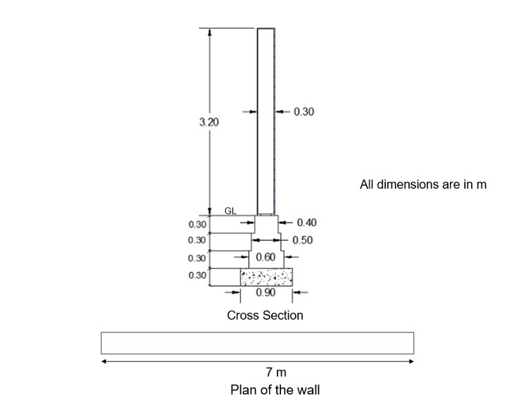

**Part C [Problem Solving Questions]**

**Answer any 3 Questions. The Question carries 15 marks. (3Qx15M=45M)**

11. Estimate the quantities of the following items using the center-to-center line method of a two-roomed building from the given plan and section.

1. Earthwork in excavation in foundation.
2. PCC in foundation.
3. 1st class brickwork in 1:6 cement mortar for foundation and plinth.
4. 2.5 cm thick cc DPC.
5. 1st class brickwork for the superstructure (wall thickness 40 cm)
6. Dimensions: Doors D - 1.2mx2.1m,

Window W – 1mx1.2m,

Shelves S – 1mx1.5m

(windows and shelves are 15 cm thick) [15 M] (C.O.2) [Application]

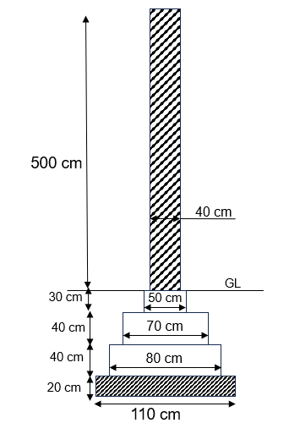

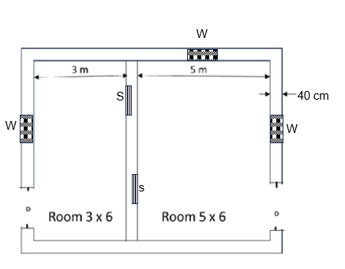

Plan

Cross section

12. A civil engineer needs to prepare an estimate before the construction of the building. There are various terminologies used in estimation. Explain the following terminology

1. Plinth area
2. Floor area
3. Circulation area
4. Carpet area
5. Site plan
6. Index plan
7. Layout plan [15M] (C.O.1) [Comprehension]

13. A two-story building is standing on a plot of land measuring 2500 sq m. The plinth of each floor is 900 sq m and the rate of plinth area is Rs 200 per sq m. The building is of RCC framed structure and the future life may be taken as 50 years. The building fetches a gross rent of Rs.20000 per month. Calculate the capitalized value of the property based on 5.4% net yield. For the sinking fund, 4% compound interest may be assumed. The cost of land may be taken as Rs. 1200 per sq m. For the building, they pay a property tax of 15%, municipality tax of 10%, management charges of 6%, and other miscellaneous charges of 3% from the annual gross income.

[15 M] (C.O.3) [Application]

14. (a) Calculate the earthwork for 400m length for a portion of a road in uniform ground the heights of the banks at two ends being 1m and 1.4m. The formation width is 15m and the side slope is 2:1 (Horizontal: Vertical). Assume there is no transverse slope. (Use all 3 methods)

(b) The estimation is the first and foremost step for any type of construction for financial planning. Explain the various factors as an engineer you would consider when you are preparing a detailed estimate. [15 M] (C.O.3) [Application]