|  |  |  |  |  |  |  |  |  |  |  |  |  |
| --- | --- | --- | --- | --- | --- | --- | --- | --- | --- | --- | --- | --- |
| Roll No |  |  |  |  |  |  |  |  |  |  |  |  |



**Presidency University**

**Bengaluru**

**SCHOOL OF ENGINEERING**

**SUMMER TERM END TERM EXAMINATION AUGUST 2024**

**Date**: 05-08-2024

**Time**: 1:00PM – 4:00 PM

**Max Marks**: 100

**Weightage**: 50%

**Semester:**  SUMMER TERM

**Course Code**: CIV3002

**Course Name**: Analysis of Indeterminate Structures

**Program & Sem**: B.Tech (V Sem)

**Instructions:**

1. *Read all the questions carefully and answer accordingly.*
2. *Question paper consists of 3 parts.*

**Part A [Memory Recall Questions]**

**Answer any five Questions. Each Question carries 5 marks. (5Qx 5M= 25M)**

1. Determine the support reactions for the simply supported beam loaded as shown in the figure.

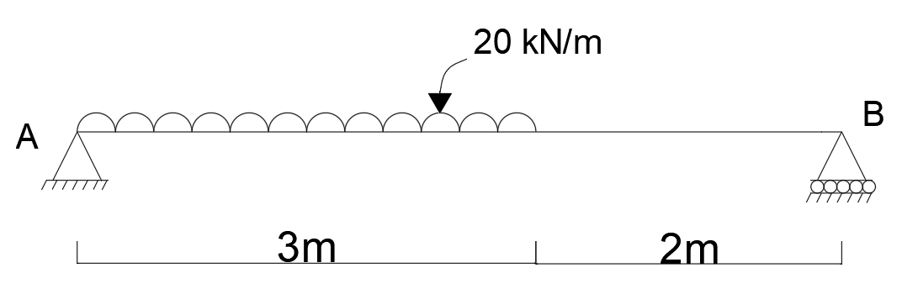

(C.O.1.) [Apply]

2. Explain the various types of beams with a neat sketch. (C.O.1.) [Comprehension]

3. Determine the support reactions for the simply supported beam loaded as shown in the figure.

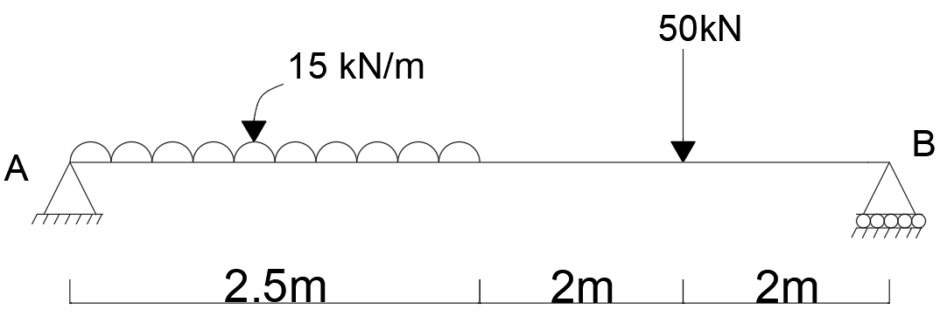

(C.O.1.) [Apply]

4. Explain the various types of support and support reactions. (C.O.1.) [Comprehension]

5. Explain the various types of loads. (C.O.1.) [Comprehension]

6. Explain the slope deflection method of analysis of indeterminate structures. (C.O.2.) [Comprehension]

7. Explain the moment distribution method of analysis of indeterminate structures.

(C.O.3.) [Comprehension]

**Part B [Thought Provoking Questions]**

**Answer any three Questions. Each Question carries 10 marks. (3Qx10M=30M)**

1. Analyse the continuous beam shown in the figure by slope deflection method. Take EI = constant.

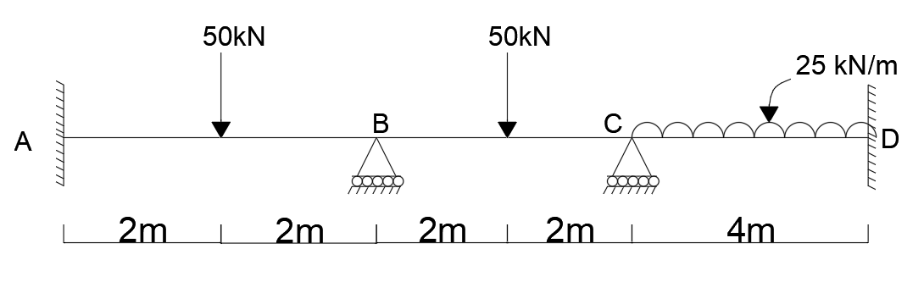

(C.O.2.) [Apply]

1. Analyse the continuous beam shown in the figure by slope deflection method. Take EI = constant.

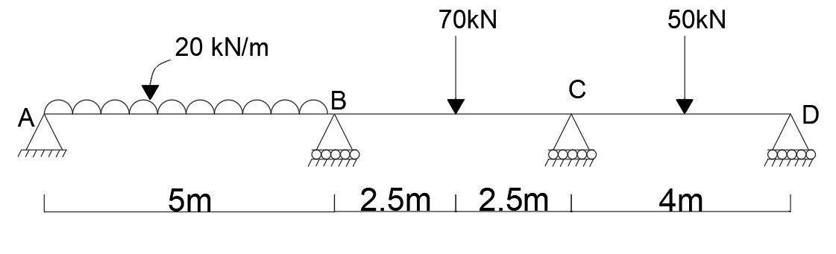

(C.O.2.) [Apply]

1. Analyse the continuous beam shown in the figure by Moment distribution method. Take EI = constant.

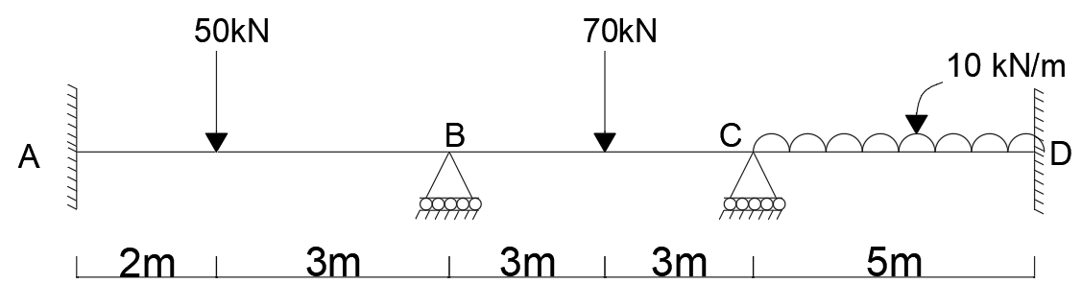

(C.O.3.) [Apply]

1. Analyse the continuous beam shown in the figure by Moment distribution method. Take EI = constant.

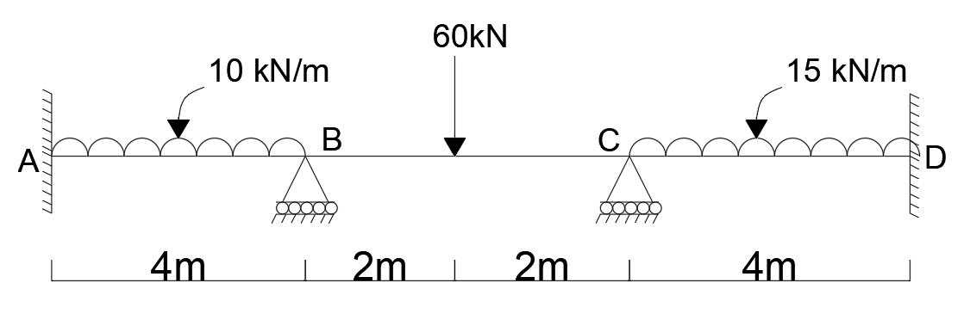

(C.O.3.) [Apply]

**Part C [Problem Solving Questions]**

**Answer any three Question. Each Question carries 15 marks. (3Qx15M=45M)**

1. Analyse the 2D portal frame shown in the figure by slope deflection method. Take EI = constant.

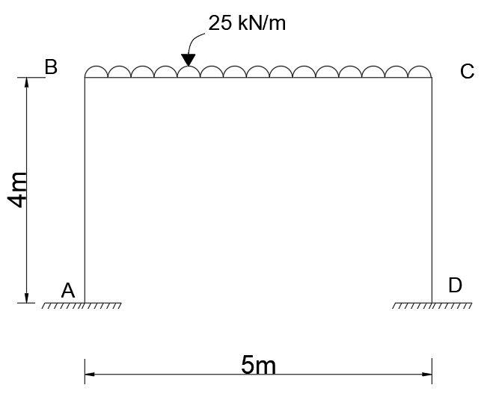

(C.O.2.) [Apply]

1. Analyse the 2D portal frame shown in the figure by slope deflection method. Take EI = constant. Point load is acting at midspan.

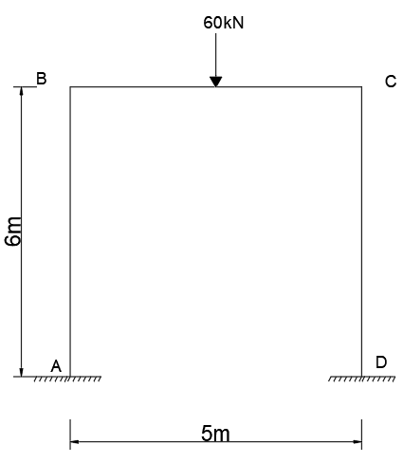

(C.O.2.) [Apply]

1. Analyse the 2D portal frame shown in the figure by Moment distribution method. Take EI = constant.

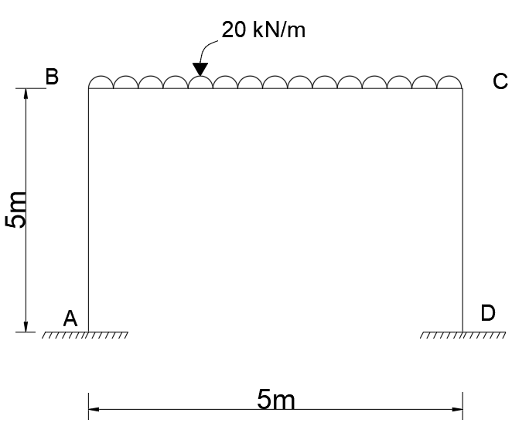

(C.O.3.) [Apply]

1. Analyse the 2D portal frame shown in the figure by Moment distribution method. Take EI = constant. Point load is acting at midspan.

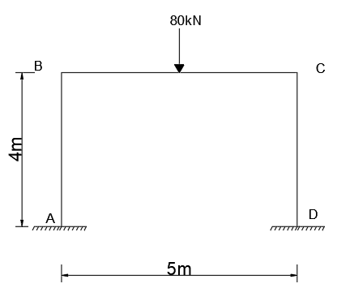

(C.O.3.) [Apply]