|  |  |  |  |  |  |  |  |  |  |  |  |  |
| --- | --- | --- | --- | --- | --- | --- | --- | --- | --- | --- | --- | --- |
| Roll No |  |  |  |  |  |  |  |  |  |  |  |  |



**Presidency University**

**Bengaluru**

**SCHOOL OF ENGINEERING**

**SUMMER TERM END TERM EXAMINATION AUGUST 2024**

**Date**: 05-08-2024

**Time**: 01:00 PM – 04:00 PM

**Max Marks**: 100

**Weightage**: 50%

**Semester**: Semester VIII - 2024

**Course Code**: ECE3042

**Course Name**: MEMS and Nanotechnology

**Program**: B.Tech. (ECE)

**Instructions:**

1. *Read all questions carefully and answer accordingly.*
2. *Question paper consists of 3 parts*
3. *Scientific and non-programmable calculator are permitted*
4. *Do not write any information on the question paper other than Roll Number.*

**Part A [Memory Recall Questions]**

**ANSWER ANY FIVE QUESTIONS. (5Q x 2M = 10M)**

1. What are the four components in a MEMS System.   
    (C.O.No.01) [Knowledge]
2. Write the relationship between output voltage and applied pressure for a piezoelectric pressure sensor   
    (C.O.No.01) [Knowledge]
3. In photolithography, if a positive photoresist is used, then the pattern obtained on the substrate will be ___________ (same/different) as that of the photomask.   
    (C.O.No.02) [Knowledge]
4. Match the electrical equivalent for each mechanical element:  
    1. Mass a. Resistance  
    2. Stiffness b. Capacitance  
    3. Damping c. Inductance   
    (C.O.No.03) [Knowledge]
5. Define insertion loss associated with a RF MEMS Switch   
    (C.O.No.03) [Knowledge]
6. Identify the difference between self-inductance and mutual-inductance  
    (C.O.No.04) [Knowledge]
7. What is the critical gap as a function of the distance between two electrodes of a parallel-plate capacitor so that the stability of the system is maintained   
    (C.O.No.04) [Knowledge]

**Part B [Thought Provoking Questions]**

**ANSWER ANY FIVE QUESTIONS. (5Q x 10M = 50M)**

1. Define transducers. Justify this statement “MEMS can act as both sensors and actuators” by giving some relevant examples.   
    (C.O.No.01) [Comprehension]
2. (i) The etch rate of silicon in KOH and TMAH is 500 nm/min and 300 nm/min respectively and for silicon dioxide it is 25 nm/min and 20 nm/min. Find the etch selectivity for KOH and TMAH. (ii) The etch rate of silicon in (100) orientation if 500 nm/min, while in (111) orientation, it is 10 nm/min. Find the isotropicity of the etchant   
    (C.O.No.02) [Comprehension]
3. From the calibration curve, find (i) Range, (ii) Sensitivity, (iii) Threshold, (iv) Offset and (v) Linearity  
    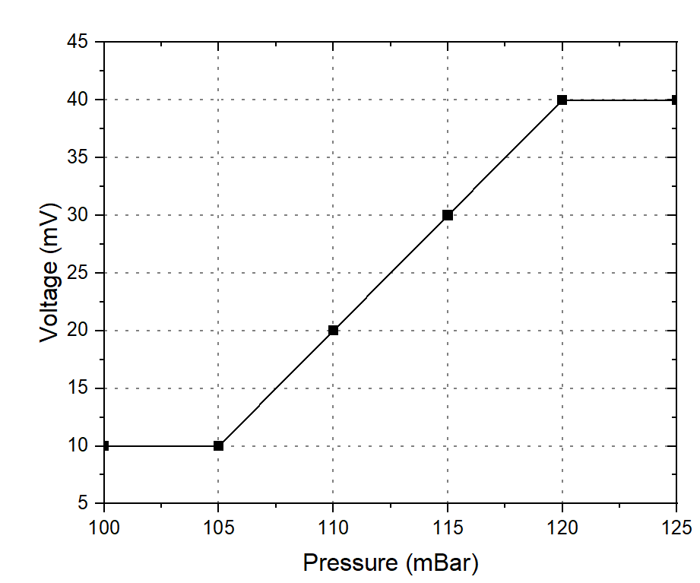   
    (C.O.No.02) [Comprehension]
4. Explain the following parameters and mention the ideal value that these parameters must possess: (i) Transition time, (ii) Switching transient, (iii) Bandwidth, (iv) Actuation voltage, and (v) Series resistance  
    (C.O.No.03) [Comprehension]
5. A RF switch is fabricated as a cantilever beam with dimensions 250μm × 30μm, with a spring coefficient of 260 N/m. The distance of separation between the electrodes is 50μm. The permittivity of free-space is 8.8E-12 F/m. Find the pull-in voltage of the switch if the dielectric used is air with a relative permittivity of 1. Also, comment on the pull-in voltage if the dielectric is replaced by silicon dioxide whose relative permittivity is 2.3  
    (C.O.No.03) [Comprehension]
6. A parallel-plate MEMS capacitor of length 100μm and width 100μm is fabricated. The electrodes are separated by a distance of 12μm using air as a dielectric. The permittivity of free-space is 8.8E-12 F/m and the relative permittivity of air is 1. Find the tuning factor of the capacitor. Compare the tuning factor if the separation of the electrodes is doubled.  
    (C.O.No.04) [Comprehension]
7. A comb-drive MEMS resonator of dimensions 205μm × 5μm × 5μm having a resonant frequency of 24 MHz is to be fabricated. If the stiffness coefficient of the beam is 400 N/m, comment on the mass required to achieve this operating frequency. Also, find the quality factor of the resonator if the bandwidth at 3dB point is 48 MHz  
    (C.O.No.04) [Comprehension]

**Part C [Problem Solving Questions]**

**ANSWER ANY TWO QUESTIONS. (2Q x 20M = 40M)**

1. (i) Explain the key processes involved in photolithography with neat diagram showing all the steps.   
   (ii) For the structure shown below, write the fabrication steps in correct sequence.  
    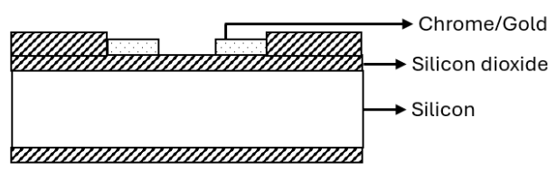   
    (C.O.No.02) [Application]
2. (i) Mention at least five advantages of using RF MEMS Switches over conventional Mechanical Switches.   
   (ii) Explain, with neat diagrams, the capacitive actuation principle to actuate a series contact RF MEMS Switch   
    (C.O.No.03) [Application]
3. (i) Using diagrams, derive the tuning ratio of a 3-plate MEMS Capacitor and compare it with a 2-plate capacitor  
   (ii) What is the disadvantage of a MEMS inductor, and show with diagram on how the problem is rectified.  
    (C.O.No.04) [Application]